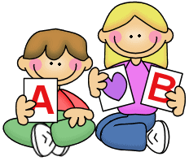





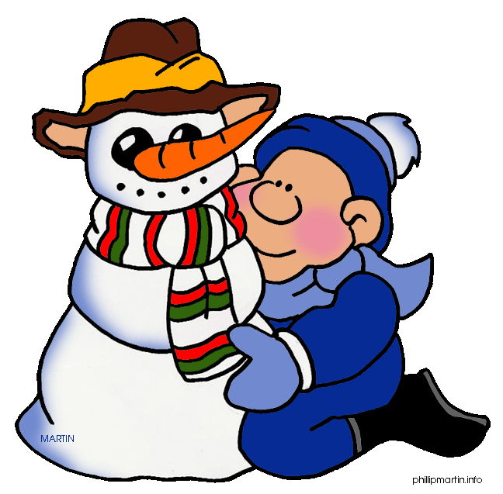
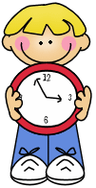

- Write the adjectives in brackets in the Comparative form.

- John Lennon was (OLD) __________ Paul McCartney.
- Some people think the Met is (GOOD) ___________ the Louvre.
- Eric was (AFRAID) ______________ in Harlem _____ in the Subway.
- Cats are (NICE) ___________ dogs.
- Cartoons are (GOOD) _____________ music programmes.
- The Empire State is (BIG) _____________ the Chrysler Building.
- Barcelona is (SMALL) ________________ Madrid, but (BIG) ___________ Valencia.

- Write the adjectives in brackets in the Superaltive form.
- Samantha is the (PRETTY) __________ girl that Paul has ever met.
- I think that King Kong was the (BAD) _____________ film ever!
- Mounth Everest is the (HIGH) ____________ mountain in the world.
- Our English teacher is the (GOOD) _____________ teacher ever!
- My room is the (CLEAN) ______________ room in my house.
- Ron is the (CLEVER) _______________ person I’ve ever met.
- The Millenium Star is one of the (EXPENSIVE) _______________ diamonds in the world.

- Write the sentences in the correct order.

- are / than / faster / Cars / bikes.
- interesting / is / than /more / History / Maths.
- than / is / exciting / New York / Albany.
- than / funnier / Comics / magazines / are
- Japan / expensive / the / country. / is /most

- Complete the table. Pay attention and don’t forget than or the.

ADJECTIVE | COMPARATIVE | SUPERLATIVE
Good
 | Nicer than
 |  | The most annoying
 | Cheaper than
Expensive
Bad
 | Bigger
 |  | The tallest
 | Prettier
Fast
 | Happier
 |  | The smallest
 | Sadier
Boring

