25
Directorate of Education/
-------------------------
English language
2015/2016
Class:2nd Grade
Date:- Name:-
Q1) Complete these sentences with the missing words (7 points)

Word bank

lion- elephant – swim – tiger – monkey – fly - bear

1-A……………can climb a tree.

2-A……………….can jump.

3- A turtle can …………..in the water.

4-A……………….can eat the man.

5-An ……………….can swing its long nose.

6-A ………………can run very fast.

7-The birds can ………………..

Q2Answer please: (10 points)

- I live in………………..



- Asma lives in………...

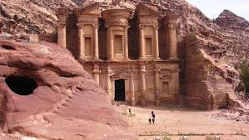

3-Mazen lives in................



4-Grandparents live in.....................



5-Ali lives in.......................

Q 3Copy:- (2 points)
- Is it agirl?

- What is the matter Asma.

Q4 Choose the correct answer please: (5 points)
- Today is............
- Sunday b- Monday c- Tuesday
- Oh my head ,I’ve got ..........
a- Ahead ache b- earache c- stomachache
3-Eleaphants are.......................
a- small b- big c- fast
4-Ababy can.......................
a- fly b- swim c- walk
5-I,m ill you must go to the.................
- doctor b- school c- dentist

Q5 Draw your favourite animal? (1 point)

WITH MY BEST WISHES
TEACHER :

