The Ministry of Education
The Education Directorate of---------
First Exam first Term
Class: 2nd Grade (Action Pack Language English
Date:

Name: ...................................................................................................................
(10 marks)
Word bank

:-
Irbid - Amman - Petra – Aqaba- Jerash

1-I live in ----------------- 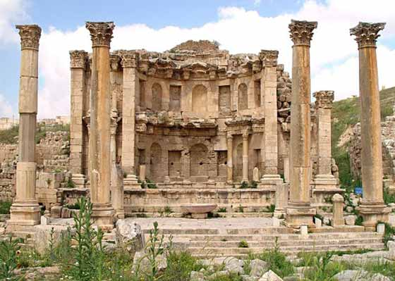
2- Sami lives in -------------- 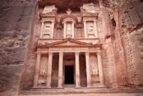
3- Asma lives------------ 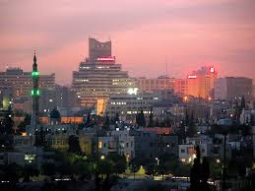
4- My grandparents live in ------------ 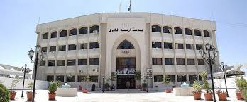
5- My uncle live in------------------- 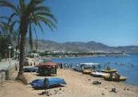

QUESTION TWO : read and colour (6 marks)
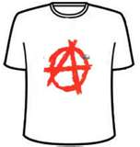

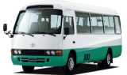

Red bus yellow book blue T- shirt

QUESTION THREE Ask and answer ( 3 marks )
On under in
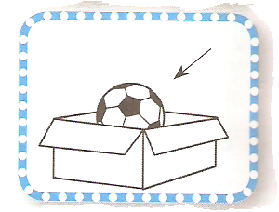
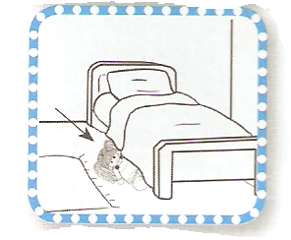
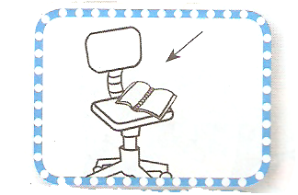

Where is the ball ? Where is the doll ? Where is the book ?
It is ------- the box. It is ----------- the bed. It is ------- the chair.
QUESTION four:-Choose correct answers(2marks):
1-Is it a boy? 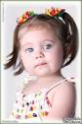
Yes ,it is No, it isn't

2- Is it a girl? 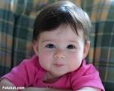
Yes ,it is No, it isn't
(4 marks) QUESTION five 1- Match please:-




2- Write please ………………………………………………………………………………………………………………………………………………………………………………………………………………………………………………………………………………………………………………………………………………………………………………………………………………………………………………………………………………………………………………………………………………………………………………………………………………………………………………………………………………………………………………………………

------------------------------------------------------------------------------------------------------------------------------------------------------------------------------------------------------------------------------------------------------------------------------------------------------------------------------------------------------------------------------------------------------------------------------------------------------------------------------------------------------------------------------------------------------------------------
--------------------------------------------------------------------------------------------------------------------------------------------------------------------------------------------------------------------------------------------------------------------------------------------------------------------
GOOD LUCK

