
Education Departmen / Zarka Area
Diagnostic Test / 4th Grades
School: Amir Hasan elementary Boys /2
Date : \ 9 \ 2017 Class : ^{4th} ( )
Name: -------------------------------
_________________________________________________________________________________________
PART ONE
Question One: Reading Comprehension (5 points)
-Read the following text carefully and then answer all the questions below:

I like my school. Islamic Education and English are my favourite lessons. I visit my grandparents on Friday and Saturday.
My father is a doctor. He works in a hospital in Aqaba.
My mother is a teacher. She works in a school in Aqaba.

Best wishes,
Majeda

1- Majeda's favourite lesson is ……………………………
a-Arabic b- Islamic Education c- Maths

2-When does Majeda visit her grandparent?
........................................................................................................................................................................

3- Majeda's father is………………………………………………………………………………………

4-What does Majeda's mother do?
........................................................................................................................................................................

5-Does Majeda's mother work in a hospital? a- Yes, she does b-No, she doesn't

.PART TWO
Question Two: Focus on Vocabulary (2 points)
A-Read and match :-( point)
1-Does Ali like football? a- He's a pilot

2- Is your mum a teacher ? b-Yes, we do

3- Do we have Moths on Monday ? c- No, he doesn't

4- What does Ali do? D- Yes, she is

1 ------- 2 ---------- 3 -------------- 4 --------------

QUESTION THREE Answer about yourself 4 marks
1- What's your name ? ------------------------------------------------------
2- What's your favourite day ? -------------------------------------------------
3- What is your favourite season ? ---------------------------------------
4- What is the weather like today ? ---------------------------------------
QUESTION FOUR Look and match ( 2 marks )

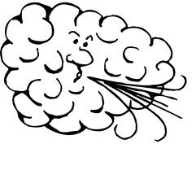
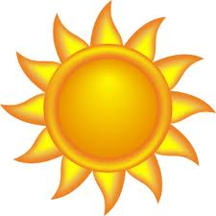


windy Sunny snowman rainy
----------------------------------------------------------------QUESTION FOUR Read and complete ( 5 marks )
( doing - please - pilot - cold - summer )
1- What are you ---------------------- ? I'm reading a book .
2- What would you like ? I'd like salad, ---------------------
3- It's -------------------- in winter .
4 – What does your father do ? He's a --------------------- .
5 – It's hot and sunny . It doesn't rain . It's -----------------

2) Copy the sentence ?): (3 points)
Ibrahim is a chef .He works in a restaurant
.

QUESTION Five Read and Write ( 4 marks )

am is are
- I --------- going to eat a sandwich .
- They --------- playing football
- She -------- going to have a party
- Ibrahim ----------- watching television .

Good Luck
English teacher Emad Sbeihat

