Worksheets
First Semester/ fourth Grade
Unit 1-4

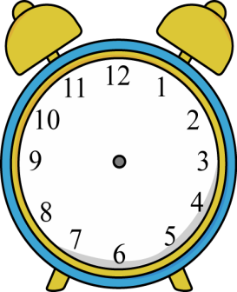

AnswerandComplete.

What’s the time?

Example

It’s half past twelve

Complete.

Always,never

We …………………………shout in class.
- She………………………..plays volleyball in the sports centre.
- They ……………….go to school on Friday.
- I ……………….do my homework.
- Dad ………………..goes to the mosque to pray.

Order and Write.
- favourite–My–is–sport–handball.

………………………………………………………………………………………..…

playing–He–likes–tabletennis.

…………………………………………………………………………………..………

always–books–in–We–read–the–Library.

…………………………………………………………………………………

sometimes–breakfast–in–We–have–the–restaurant.

…………………………………………………………………………………

3


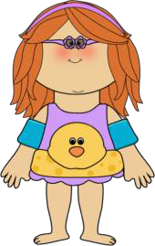
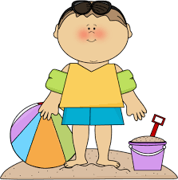

ReadandAnswer.

MynameisHeba.IalwaysgotoAqabaonFridaywithmybrotherAhmadbybus.Manypeople visitAqabaevery year.We like swimmingverymuch.We sometimes gosailingwithourfriendsat6o’clock.Iwanttobuypresentsformyfamilyandfriends.Mybrothersometimeswatchesvolleyballmatches,inthebeach.Ican’tplayfootballbutIlikehandballalot.
Heba

HebaandAhmad always goto Aqabaon…………………….
  - Theywantto……………………..……………fortheirfamilyandfriends.
  - WhatsportsdoesHebalike?
………………………………………………
4. CanHebaplay football?
………………………………………………
5. Whendo theygosailing?
………………………………………………
6. WheredoesAhmadwatchvolleyballmatches?
………………………………………………
7. Howdotheygoto Aqaba?
……………………………………………………
8. True/False: √,×

Ahmadnever watches footballmatches. ( )

They goto Aqababy car. ( )





Ask and answer

- Ishewritinganemail?
……………………………………………………

…

- Aretheygoodatrunning?
…………………………………………………………


- Dotheylikeexercise?

…………
…………………………………………


- Aretheyhavingfun?

……
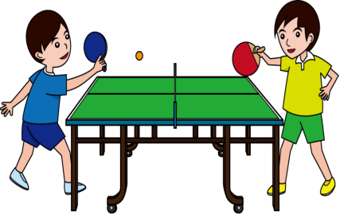
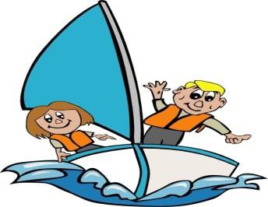
………………………………………………

- Whatistheirfavouritesport?
…………………………………………………………………………………....…

……………

- Whataretheygoodat?
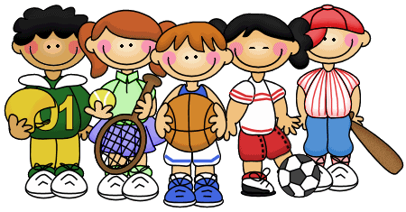
………………………………………………………………..…7.Wheredotheyplaysports?
………………………………………………………………..……………

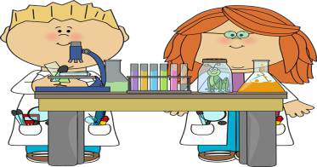
- WheredotheyhaveScience?
………………………………………………………………..……………




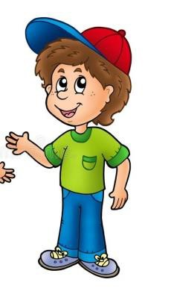



Completethe dialogue.

What sport are you

good at playing?

What is your

favourite sport?

Are you good at playing
Table tennis?

Can you sail?









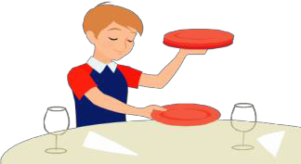
Yes, I am.

No, I am not

ReadandCircle.


Whatareyoudoing,Salma?
I’mreadingabook.
I’mdoingmyhomework.

WhatdoesAlilikedoing?

Helikesridinghisbike.Helikesdrivinghiscar.

WhatisAhmaddoingnow?

He’ssettingthetable.
He sets the table.

AreyoulearningEnglish?

Readandcircle.

  - I(always,never)getupearly.

  - Ilike(play,playing)tabletennis.

  - WehaveP.E.inthe(hall,lab).

  - Myfavouritesubjectis(running,Arabic).

  - Myfavouritesportis(run,running).

  - Theboys(like,likes)travellingbytrain.

  - I’m(isnot,not)goodatusingcomputers.

  - Idomyhomework(before,after)school?

  - Myteacheris(send,sending)anemail?

  - Wearegood (in,at)playing table tennis.

  - Look!Hebais(drive,driving)hernewcar.

- Farahcan(use,using)thecomputer.

8

Writewithcapitalletters.

Juan is sending anemailtoheba.
………………………………………………………………………………………….

Mymotheristravelling towadirum onoctober.
………………………………………………………………………………………….

ilike visitingaqabaonfriday.

………………………………………………………………………………………….

ahmadislearningaboutpalestine.
………………………………………………………………………………………….

Completethepunctuation. (? .)

IsKhaliddrivinghisnewcar

- Noorcan’t playfootball

- Doyou havescience lessons inthe lab

- Whogoesshoppingwithyou

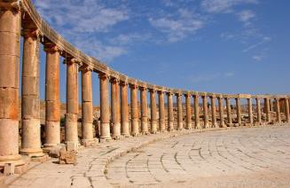
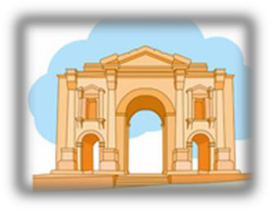

Readandorder.
Thankyou.
WhatareyoureadingHeba?
Doyouhavegamesonyourcomputer?I’mreadingabookaboutcomputers.
Yes,Ido.Comewithme,let’splayagame.



ReadandAnswer.
DearSami,
I’mgoingtoJerashthisFridaywithmyfriendHani.Mycousinisdriving.We’regoingonMondayat7o’clock.Jerashisaveryoldcity.IlikevisitingJerashinsummer.Theweatherissunny.WelikewalkingthroughthecolumnsofJerash.Wesometimesgoshoppingintheoldmarket. HereisaphotoofJerash.
Majed
- MajedisgoingtoJerashby(bus–car).
- MajedlikesvisitingJerashin(spring–summer).
- Majed(always–sometimes)goesshoppingintheoldmarket.
- WhenisMajedgoingtoJerash?
……………………………………………………………………………………………………
- WheredoesMajedlikewalking?
……………………………………………………………………………………………………………
- IsJerashanewcity?
……………………………………………………………………………………………………..
- HowistheweatherinJerash?

..............................................................

