
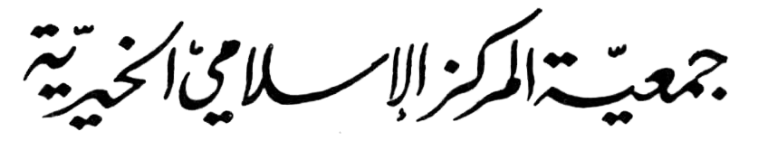

ورقة عمل
المادة : الرياضيات .
الاسم ....................... الصف :الرابع عنوان الورقة :مراجعةحقائق الجمع التاريخ : / / 2019

9 + 1 = ____ 8 + 2 = ____ 7 + 3 = ____ 6 + 4 = ____ 5 +5 = ____ 4 +6 = ____ 3 +7 = ____
9 + 2 = ____ 8 + 3 = ____ 7 + 4 = ____ 6 + 5 = ____ 5 + 6 = ____ 4 +7 = ____ 3 +8 = ____
9 + 3 = ____ 8 + 4 = ____ 7 + 5 = ____ 6 + 6 = ____ 5 + 7 = ____ 4 +8 = ____ 3 +9 = ____
9 + 4 = ____ 8 + 5 = ____ 7 + 6 = ____ 6 + 7 = ____ 5 + 8 = ____ 4 +9 = ____ 2019
9 + 5 = ____ 8 + 6 = ____ 7 + 7 = ____ 6 + 8 = ____ 5 + 9 = ____
9 + 6 = ____ 8 + 7 = ____ 7 + 8 = ____ 6 + 9 = ____
9 + 7 = ____ 8 + 8 = ____ 7 + 9 = ____
9 + 8 = ____ 8 + 9 = ____
9 + 9 = ____

معلمة المادة : سلوى ابو سمور

