Super Helper
for Parade 1

Let’s learn together unit 4, 5, 6, 7, 8 and 9…

- Match:



- Count. Write. How many?

- Count and write:

- Color: 1= purple 2= orange 3= red

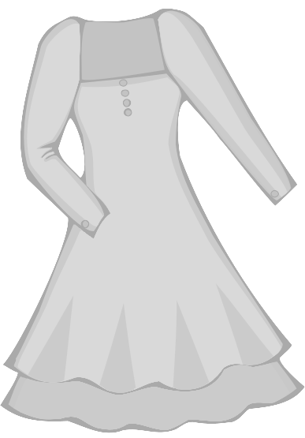

- Read and circle:

- Circle the rectangle:

- Circle the triangle:

- Circle the jacket:

- Write the missing letter:

dr……ss

shor……

……ocks

pa……ts

- Color: 1= pink 2= white 3= yellow

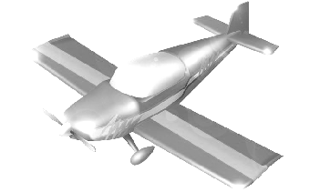

- Count. Color:

- Read and match:

- doll

- ball

- boat

- car

5. truck

- Write the missing letter:

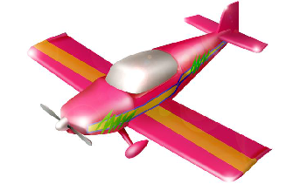
tra……n
airpla……e
gam……
……histle

- Match:

- Count and write:

- Match and color:

- taxi

- dentist

- bus

- nurse

- ten

- Read and circle:

- Circle the taxi:

- Circle the firefighter:

- Circle the dentist:

- Circle 8 circles:

- Write the missing letter:

n……rse
ta……i
d……ntist
b……s
do……tor

