Name : English Second Exam 2015 2nd Grade
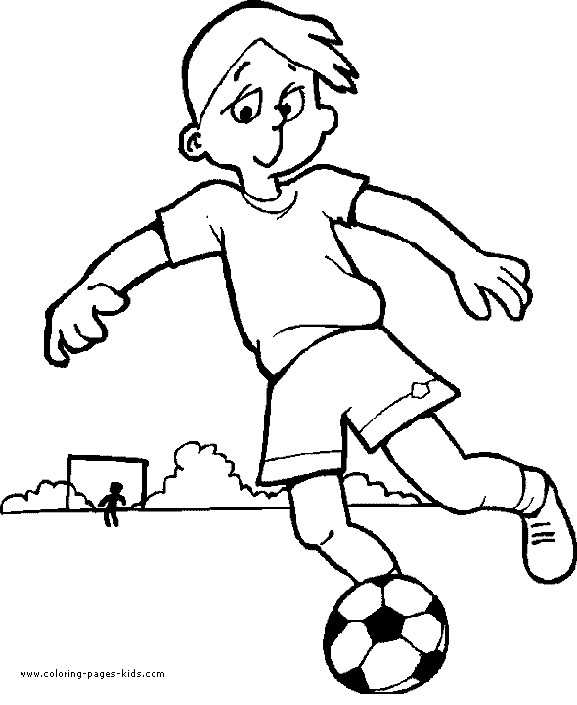
Q1 :Match (3 points)
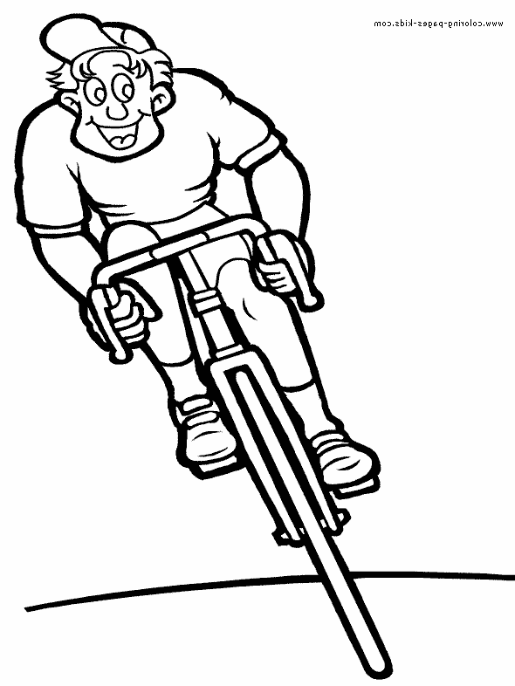
On Sunday , I read abook
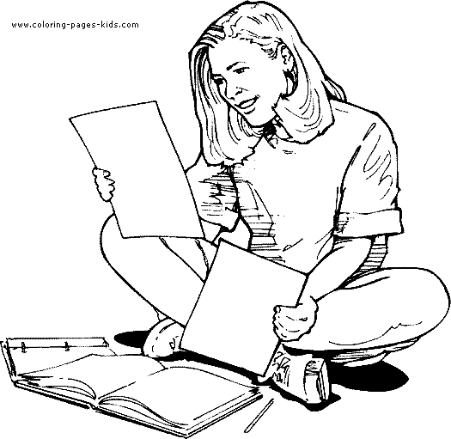
On Tuesday , I ride a bike
On Wednesday, I play football
-----------------------------------------
Q2 :Complete ( 4 Points)
Monday / Irbid / yes / park

- I live in …………….……………..
- Today is …………………………….
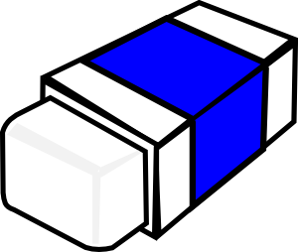
- On Tuesday, I go to the ………………………………
- Is it a rubber ? ………, it is
----------------------------------------- Q4 :Complete ( 6 points)
Sunday ………………………. Tuesday ………………………… Thursday
……………………… Saturday .
--------------------------------------------
Q3 :Circle the odd word ( 2 points)
Sunday Amman Zarqa Irbid

Rubber aunt pencil case ruler

Good luck
T. Fatima Ramadan

