Alfaisaliahpimary school/ Second Month Exam
10

Class: 2nd Grade Date:14/11/2018
Name:………………………… Time: 40 Minutes

Reading:

Q1:Read the following text then answer the questions:( 1.5 Marks )
Asma lives in Amman. On Friday, She visits the zoo. She can see animals.

1. Where does Asma live? She lives in ____________.
2. Asma visits the zoo on ____________.
3. What can Asma see in the zoo? She can see ____________.

Q2:Read the circle: ( 1.5 Marks )
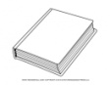
1. _____ book.
a. It’s b. They’re

2. _______ Lions.
a. It’s b. They’re

3. I can see __ elephant
a. an b. a
Speaking:

Q3: Read and complete: (1.5 Marks )
Saturday / today
What day is it ___________?
It’s _____________.
Q4: Read and match: ( 1.5 Marks )
I can see a bear. | Who is this ?
That’s my uncle. | Is it a pencil case?
Yes, it is. | What can you see?

Listening:

Q5:Listen and draw :( 3 Marks )

Q6:Listen and write: ( 1.5 Marks )

____________, _____________, Tuesday, ______________.

Writing:

Q7:Look and write:( 2 Marks )

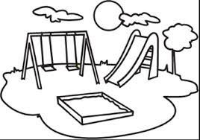

__ark __iger

Q7:Copy:( 1Mark )
On Thursday, I ride my bike.

