Lycee liberty school
Mid Term Revision
The First Term
Junior one
2015-2016

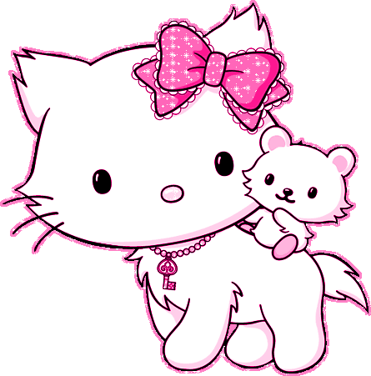

Name :--------------------------------------------------------Class:-1 /-------------------------

Class:---------------------------------------------------------------------------------------------

English World 1
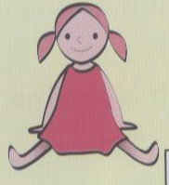
Mark the correct answers

1- It is a doll. ( Yes ) ( No )

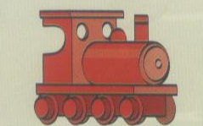
2-It is a computer . ( Yes ) ( No )

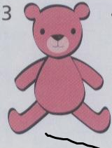

3-It is a teddy . ( Yes ) ( No )

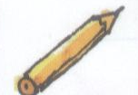

4-It is a rubber . ( Yes ) ( No )
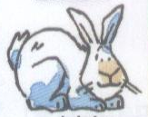

5-It is a rabbit . ( Yes ) ( No )

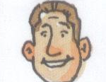
6-He is dad. ( Yes ) ( No )

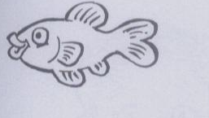

7-It is a fish . ( Yes ) ( No )

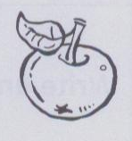
8-It is an orange. ( Yes ) ( No )

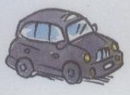
9-It is a taxi. ( Yes ) ( No )

Choose the correct answers
- Teddy is a (boy -girl- toy).
- Ahmed is a (toy – boy - girl).
- Mona is a (toy- boy- girl).
- The elephant is (big- small - tall).
- She is my (father- brother - mother).
- My name is Salma. I’m a (toy- girl- boy).
- Mazen and Marwan are my ( mother – brothers - sisters).
- (She – He - It) is a boy.
9-(It- He- She ) is a doll.
10.(He - It- She) is Lilly.
11.(Am-Is-Are) it a boat? Yes, it ( am- is -are).
12.(Am-Is-Are) it a kitten?
13.It’s a cat. (He-She-It) is small.
14.Look (on -in- at) the tree.
15.It’s a (dog- sister- crayon). It’s orange.
16.What’s (am- is) your name? (My- His- Her) name’s Ahmed.
17.What( is - are) it? It’s a ruler.
18.What is (they -we- it)? It’s a desk.
19.(It- They- He) is a rabbit.
20.Is it a cat? (Yes - No) it isn’t. It’s a rabbit.
21.He’s my (grandpa-grandma-mother).
22.She’s my (grandma-grandpa-father).
23.Lilly is riding a (bike- cat -dog).
24.He’s carrying an (cat- umbrella-dog).
25.It’s a ( cat- arm- umbrella).
26.It’s an ( ant- car- doll).
27.How (am-is-are) you? I’m fine. Thank you.
28.Good (say- bye).
29.It’s a ( orange- book - egg).
30.It’s (a- an- no) apple.
31.It’s (a- an- no) train.
32.It’s (a-an-no) egg.
33.I have (a- an- no) umbrella.
Rearrange the following:
- a - boat – is – It
-------------------------------------------------------------------------------------------
- Is – a - doll -? – it
--------------------------------------------------------------------------------------------
- name – Dan – My – is
---------------------------------------------------------------------------------------------
4.is - it – What - ?
------------------------------------------------------------------------------------------
5- rubber - ? – it – Is - a
---------------------------------------------------------------------------------------------
6.a – not – kitten . – is – It
------------------------------------------------------------------------------------------------
7.red – a – It – Lorry . – is
------------------------------------------------------------------------------------------------
8.an – It – apple . – is
------------------------------------------------------------------------------------------------
9-a – I – am – girl .
-----------------------------------------------------------------------------------------------
- you - ? – are – How
------------------------------------------------------------------------------------------------
Pictorial composition

Supply the missing parts

2  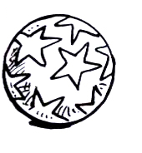 Is ----------a ball ?  ………...,it ---------------- | 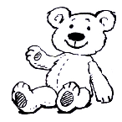  ……….is a ……………
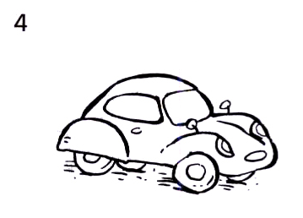  Is ---------- a train?  No,it --------------- It 's a ----------------- | 3  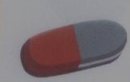It ------------a --------------------
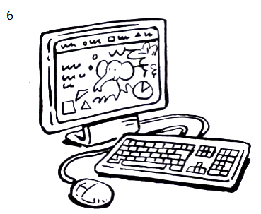  Is ………a table ?  No, it ……….It's a …………….. | 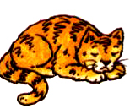5  …….. it………………?  Yes, …… … …..
7  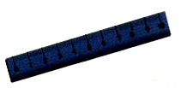  ….…………… is it ?  It …… a ……………… | 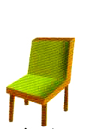  8  …………… …………. a rubber ?  No , ……… ………………………..  It's a ---------------------
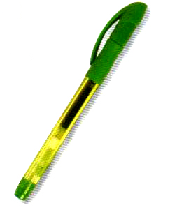9  What ……… …………?  ….……… is ………….. | 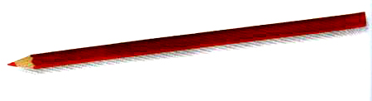10  …………… is it ?  It …… a ………......
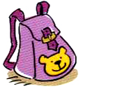11  Is it a …………………….. ?  Yes , ……………… | 12  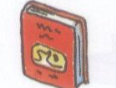  Is it a ……………………?  Yes ,…………….

13 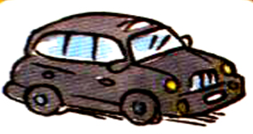  What is it ?  ………………………… | 14  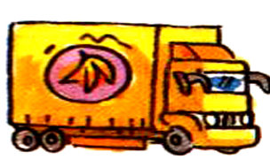  It is ……………………..
15  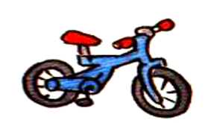…………….. is it ?  It ………………….. | 16  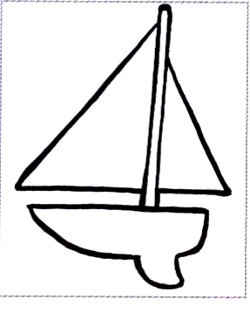  Is ………… a …………….  Yes , …………………
17  What ….. …………?  It is ………….. | 18  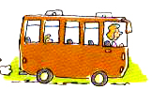  It is ………………….

Supply the missing letters

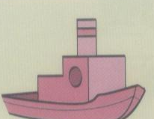  B - - at | co - p - ter  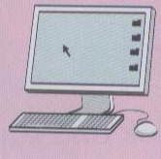 | 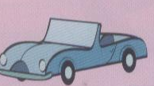c - r | P - n - il
ra – b - t | bo - - | 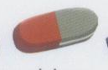  r - - ber | 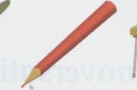  c – a - on
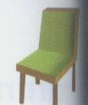  C – a - r | 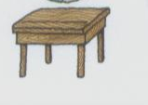  d - - k | 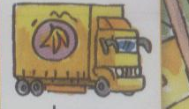  L - - ry | 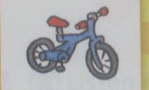  b – - e
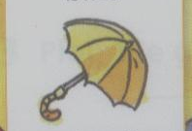  U – bre - la | 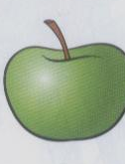  a - p - e | 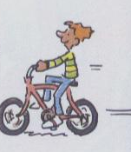  b - -e | 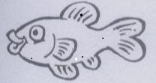  f - - h

Reader P.4-P.11
Reader ( Little Red Riding Hood)
Choose and rewrite the correct words
1-Little Red Riding Hood lives beside a big dark -----------( garden –wood)
2-Mummy brings a------------------ ( cake –sweets) one day.
3-Grandma is --------------( happy-sick) today.
4- Red Riding Hood takes the cake to -------------( grandpa –grandma)
5 Red Riding Hood mustn't --------------( stop –walk) in a big dark wood.
6-A wolf lives in a big ------------( dark-sunny) wood.
7-The wolf is bad .He isn't -----------------( happy –good)
8-The wolf is ----------( helping –watching)the Little Red Riding Hood .
9-The wolf wants to -------------------(eat –help)red Riding Hood.
Put ( √ ) or ( X )
1-Little Red Riding Hood wears black hood . ( )
2- Little Red Riding Hood lives in the garden. ( )
3-Grandma is sick today . ( )
4- Little Red Riding Hood takes sweets to grandma ( )
5- A cat lives in the dark wood. ( )
6-A wolf is watching the Little Red Riding Hood ( )
7-The wolf wants to eat the dog. ( )
Hand writing
She has got an umbrella

The children are swimming in the sea.

