Unit 8
I’ll tidy up
New words :Write the words correctly:
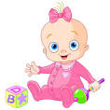
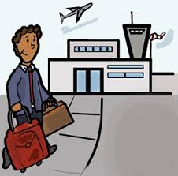

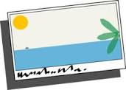
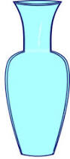

Use the previous words to complete the sentences:
1-My uncle has a ______________.He drinks milk.
2-My father went to the ____________.He wants to travel to Egypt.
3- I have got a very beautiful ____________ it is a book .
4- I bought these flowers .Let’s put them in the __________
5- Laila send me a _____________ it was about petra.

Grammar :
We use the future simple with all pronouns +will and the base form of the main verb.
She will go to school tomorrow.
Simple Future

Time expressions used with the future simple
Tomorrow, the day after tomorrow, next /week/month/year/, tonight, soon.

Complete the following sentences using the future simple:
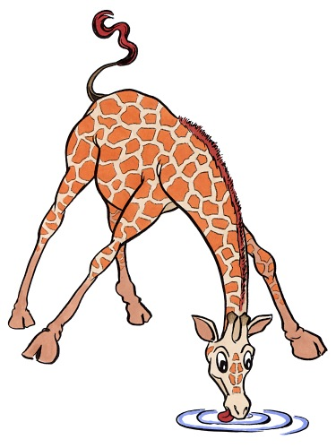
1-A: Your room is a mess.
B: I ……………………. it .( tidy)
2 A: you haven't done your home work yet?
B: I …………………………. it tonight.( do)
3- A:The sound is too loud .
B: Okay! I ……………………. it down. (turn)
4- Laila ……………….. football on Sunday morning.( play)

Writing practice:
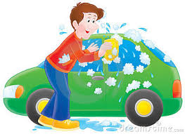
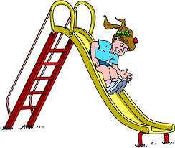
Write meaningful sentences using the simple future :

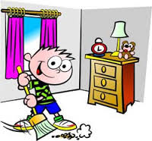
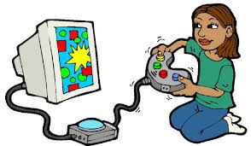
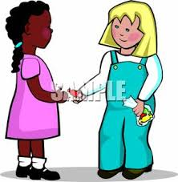

Simple Past - Use
The Simple Past is used to talk about actions or situations in the past. It is also called Past Simple.
Have a look at the following examples:

1) action finished in the past (single or repeated)
I visited Berlin last week.
Andrew watched TV yesterday

2) series of completed actions in the past
First I got up, then I had breakfast.
The Simple Past is used to talk about actions or situations in the past. It is also called Past Simple.
Have a look at the following examples:

1) action finished in the past (single or repeated)
I visited Berlin last week.
Question one: Correct the verbs between the brackets:
1-The police……………………. the thief yesterday.(catch)
2- I ……………….…. The lion in the zoo last week.( see)
3- Laila ……….……. at school yesterday.(be)
4- We ………………. a letter last year. (write)
5- I …………..….. the cakes last night.( eat)
6 - My brother _______ his leg last night.(break)
7- I ___________my lectures last week.(begin)
8- Samia _________ in the pool yesterday.(swim)
Unit 9
We went to the airport

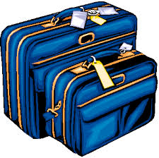
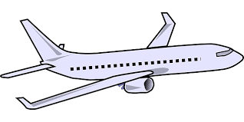
New words:

Use the following words to fill in the blanks:
/passports-customs-journey-airport/
-1-We travelled to Egypt. We take the plane from the ______________
-2- The airport officer asked to see our ________________
-3- After we collected the suitcases we went through the _____________
-4- I think it will be a great ______________ to Lebanon.
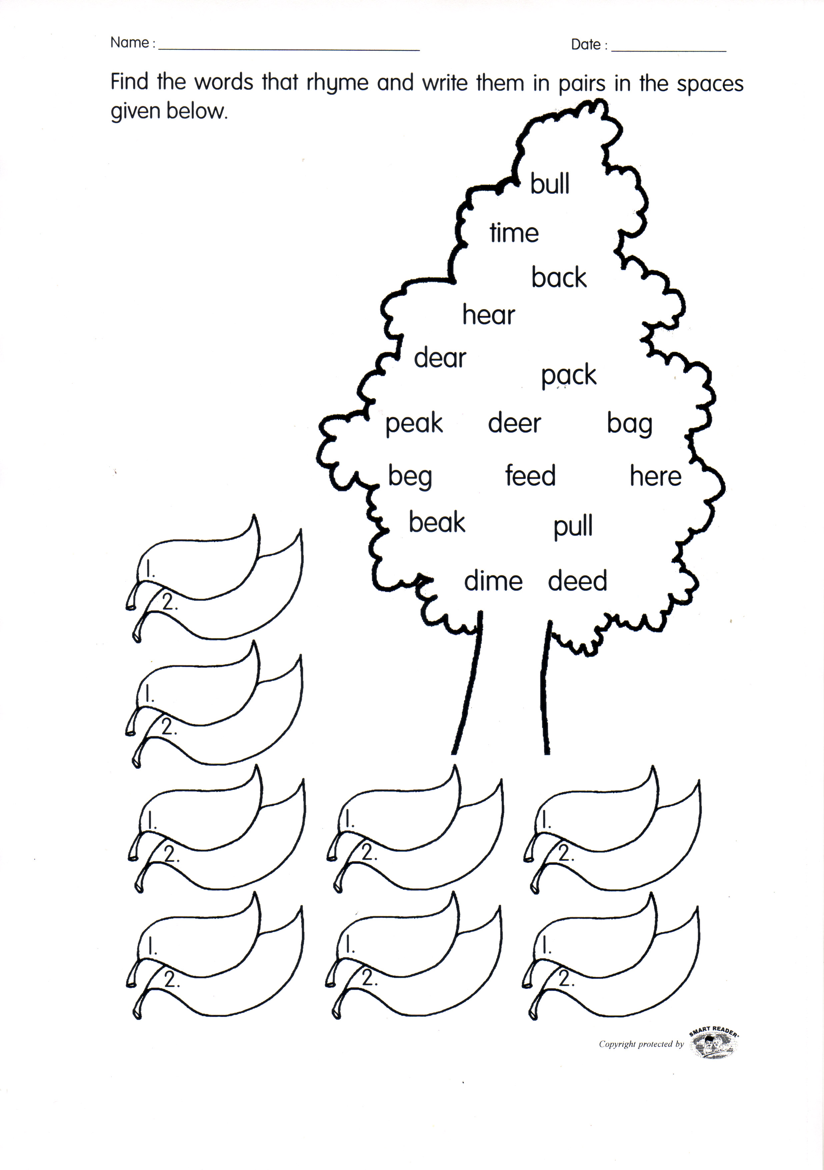
_____________________________________________________________
Phonics:

: Past Continuous
Form : was/were + present participle + /simple past
Keywords : When –while

•I was watching TV when she called.
•When the phone rang, she was writing a letter.
•While we were having the picnic, it started to rain.
• What were you doing when the earthquake
started?
•You were not listening to me when I told you to turn the oven off.
- While John was sleeping last night, someone stole his car.
___________________________________________________________________
Correct the verbs between the brackets:
1-I ____________ when she made dinner./ study/
2)While Ellen _______________, Tim watched television. /cook/
3)We listened while he _______________/talk/
4)I wasn't paying attention while I ____________ the letter, so I made several mistakes/write/.
-5- I __________ Ali. when I was walking in the street./see/
-6- They collected the bags while she _________________./sleep/
-Laila ___________the pictures while she was walking in the garden./take/

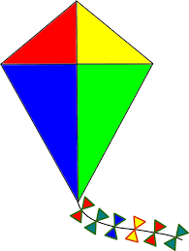
Unit ten
Could you fly a kite?

New words:
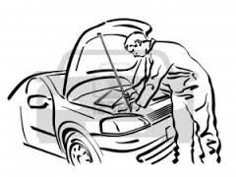
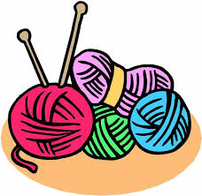
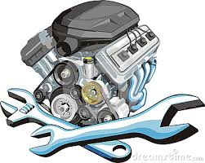
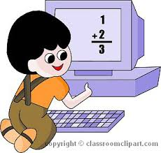
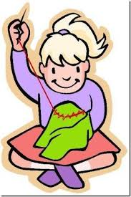
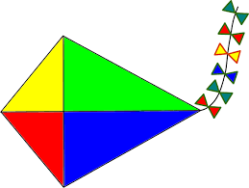

_____________________________________________________________
Complete the following sentences using the given words:
- knit-fly-engine-sewing machine -
*Ali could ________ the kite when he was six.
*He likes mending car’s ____________
*I could sew using the ____________
* I use wool to _________ clothes
We use could to show that some one had the ability to do something in the past.

Mariam could use a computer when she was 10.

*Could Mariam use the computer when she was 10?
Yes, she could.
* Could Mariam use the computer when she was 3?
No, she couldn't
Use could or couldn't:
- __________ you play the football when you were five ?
- I lost my keys and I ___________ find them anywhere.
- I __________ count when I was three.
- I __________ drive a car when I was young.
- She ________ speak English when she was 13 years old.
_____________________________________________
Circle the correct answers:
- Laila could ______________ when she was ten .
a-wrote b- write c- writing
- Sami couldn’t ___________ speak English when he was five .
a- reading b- reads c-read
- Ahd could __________ when she was fifteen.
a- cook b-cooks c- cooking

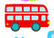
Project : make a story about a bus trip

What?
Problem
Where?
Story
Who?
Solution

Unit eleven
It’s from the past
New words :
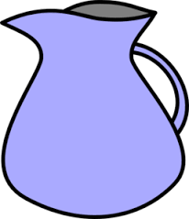
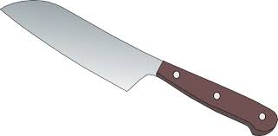
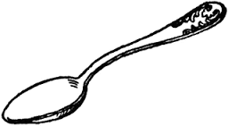

_____________________________________________________________
Phonics : the vowels Fill in the missing vowels then read the words
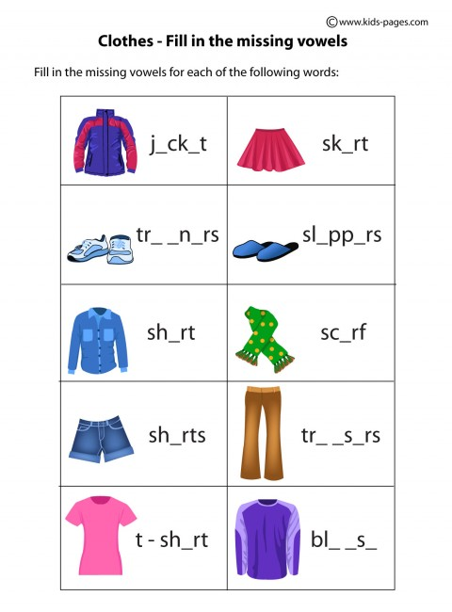

Adjective order :
Adjective : A word that describes the noun .
You may have more than one adjective in a sentence .How to order them?
Opinion: beautiful-interesting-great
Size-shape : big- small-round-oval
Age : old –new
Color: red –brown-blue-yellow
Material: wooden-metal-rubber-glass-clay
Thing: table-ball-vase-pot-woman .
Example :
Metal- clock -round- great- old silver
Material thing shape opinion age color
It is a great small round old silver metal clock
_____________________________________________________________
Order the following adjective to form new sentences:
- table-wooden-red-small-great.
It is a ______________________________________
- vase-glass-green-big-beautiful .
It is a ___________________________________________
- lady-young-brown-beautiful-tall
She is a _______________________________________
Unit twelve:
Let’s do an experiment
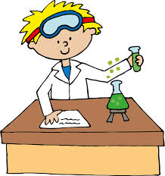
New words :
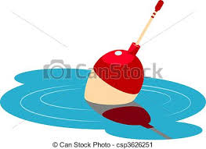
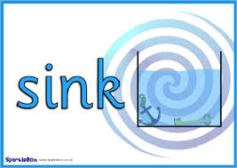

_________________________________________________________
Color the verb( green) the noun( orange )and the preposition (yellow )
Park | on | go
swing | holiday | do
in | mum | Make
help | planes | to
Happen | Experiment | Sink

Unit thirteen
I want to be a programmer
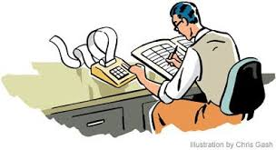



New words : Occupation and jobs:
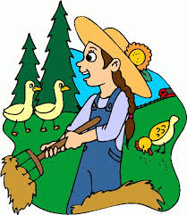
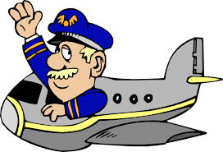
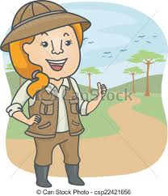
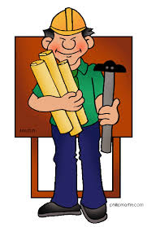

_____________________________________________________________
Write sentences : What does he do?:
An architect:___________________________________________________
A teacher:_____________________________________________________
A dentist :____________________________________________________
_____________________________________________________________
Say Who?
*He grows food:_____________________
*He flies planes:_____________________
*He guides tourists :_____________________
Reading &Comprehension
Read the following text carefully & answer the questions that follow :
Keeping Up With The News
Newspapers contain news, information and advertising, and printed on low –cost paper. They can be daily or weekly, national or local. Newspapers used to be hand written and used to be passed from person to person. They had information about wars, economic conditions, social customs and human interest features. The news editor holds a meeting where they decide what stories to publish. They also decide where the photos and advertisements will go.
Newspapers are cheap because half the cost is paid for by advertising .The oldest newspaper still in existence was first in Austria in 1903.

Q1:Write True( ✓ ) or False( ✗ ) ☹
1- The oldest news paper was in Austria in 1903: ____________
2- News papers were cheap in the past: _________
___________________________________________
Q2: The word that means given is :_______________
___________________________________________
Q3: What do news paper contain ?
____________________________________________________________________________________________________________________________________________
Q4: Why are newspapers cheap ?
____________________________________________________________________________________________________________________________________________
Q3:Match the meanings
(rich – Journalist – expensive – hand written )
- The opposite of printed :_____________
- The opposite of poor :________________
- High cost :____________
Q4:The underlined pronoun They refers to :______________
Write the correct name (Robber , thief)
1- My classmate stole my pencil yesterday.__________
2- A man stole the bank and used the gun to shot my brother :____________
_______________________________________________
Q1: Complete the following sentences .Use the simple past and past continuous:
1- She _____________(walk) to work when she __________ (see) Ahmad.
2- Ron ___________ (hurt ) his knee while he ____________(play) basketball .
3- We _____________(run ) when it _____________(start) to rain .
_________________________________________________________________
one of the following relative pronouns who, which or whose from the dropdown menu.
1) I talked to the girl car had broken down in front of the shop.
2) Mr Richards, is a taxi driver, lives on the corner.
3) We often visit our aunt in Norwich is in East Anglia.
4) This is the girl comes from Spain.
5) That's Peter, the boy has just arrived at the airport.
6) Thank you very much for your e-mail was very interesting.
7) The man, father is a professor, forgot his umbrella.
8) The children, shouted in the street, are not from our school.
9) The car, driver is a young man, is from Ireland.

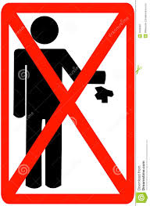
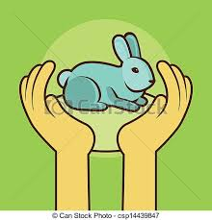
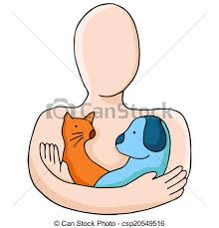
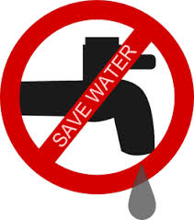
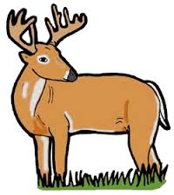

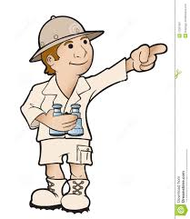
Unit fourteen
Will they become extinct

________________________________________________
Q7 :Read and complete the sentences:
(always-yet-already-ever-never)
- I have _________ wanted to be a musician.
- I've __________learnt to play many songs on the piano .
- I haven't ___________played the lute.
- Have you __________ played the piano?
I haven't won any competitions_________

Reading &Comprehension
Read the following text and answer the questions after :
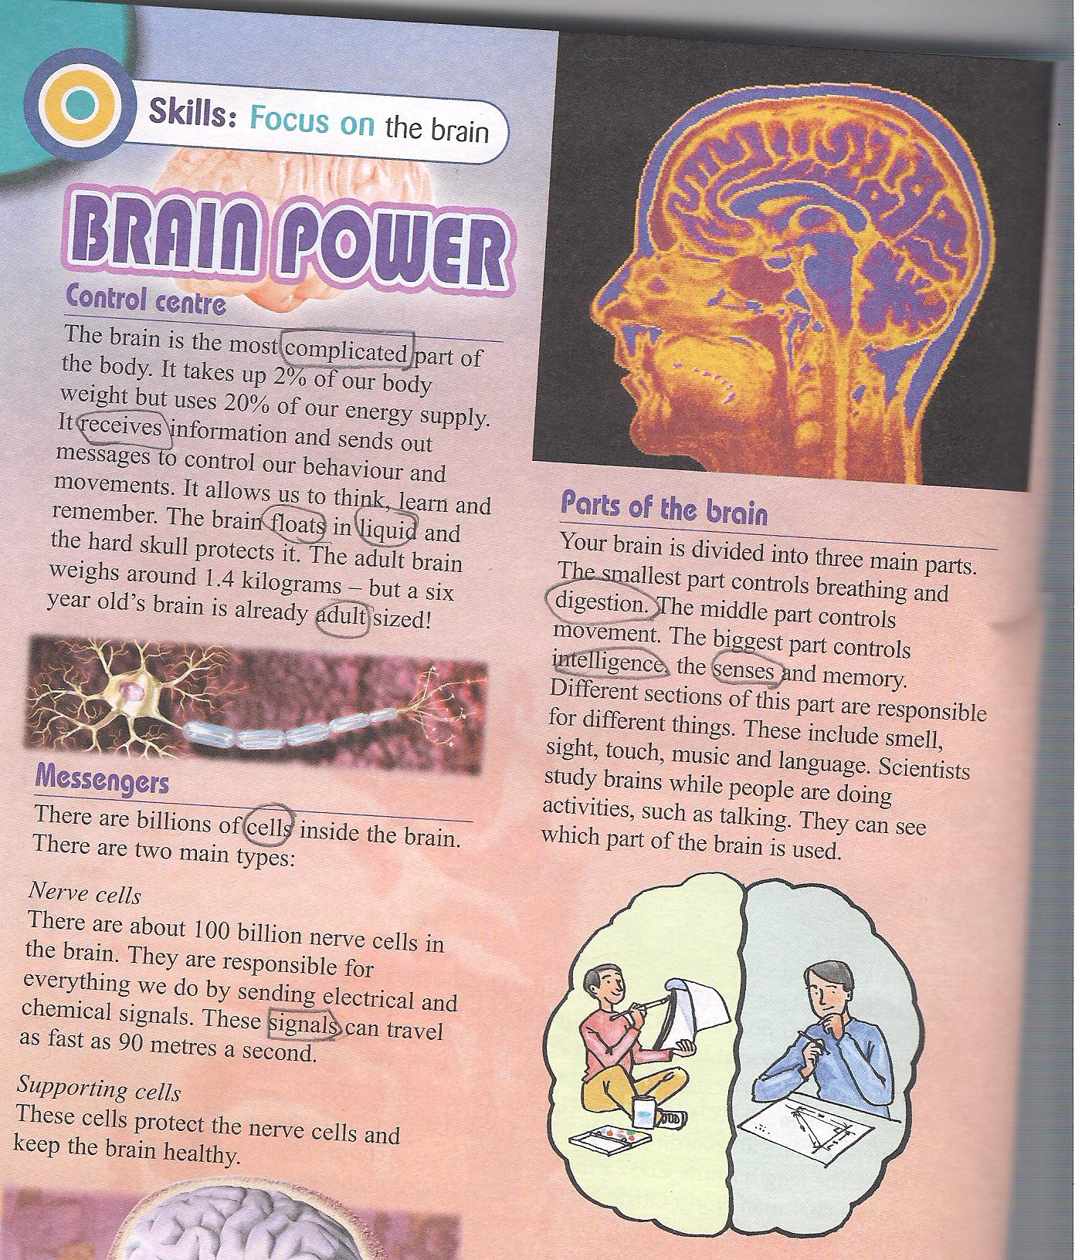

The brain is the most complicated part of the body.It took 2%of our body weight .It receives information and sends out messages to control our behaviors and movements.
There are two main types of cells ,Nerve cells and Supporting cells .Nerve cells are responsible for every thing we do by sending electrical and chemical signals. Supporting cells protect the nerve cells and keep the brain healthy.
The brains has three parts. The smallest part controls breathing and digestions. The middle part controls movements .The biggest part controls intelligence, the senses ,and memory .The brain has two halves ,the left side is used for creative activities .The right side is used for logical activities .

Q1 : Write True or False.(Correct the false ones )
- The right side of the brain is used for breathing :__________
_____________________________________
- The biggest part of the brain controls movements :_________
_______________________________________
- The brain took 2% of our body weight :________
_______________________________________

Q2 :What does the brain do ?
______________________________________________________________________________________________________.
Q3: What do nerve cells do ?
_____________________________________________________________________________________________________.
Q4:-What do supporting cells do ?
___________________________________________________
Q5:- What do the smallest and the middle parts of the brain control?
_______________________________________________________________________________________________________________________________________________________________________________________
Q6:Find words in the text that mean the following :
- Complex ,Difficult to understand :________________
2- The smallest living part in the human body: _____________
3-The process of changing food in the stomach:______________
_________________________________________________
Q8: The underlined pronoun it refers to ____________
_________________________________________
Complete the following sentences using the given words :
( sense, intelligence, received , floating, adult)
- This film is suitable for both ___________ and children.
- I ____________ a letter from an old friend .
- There was something ___________ near the bank of the river .
- Exams are the best way to measure_____________
- I have cold and I have lost my ____________ of smell .
_____________________________________________________________

