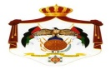
THE MINISTRY OF EDUCATION
THE UNIVERSITY BRIGADE
Hafssah Bent Omar Secondary School
FINAL EXAM- FIRST TERM /3RD GRADE
Name :--------------------------- Day:--------- ------
Time:- One hour DATE :- / / **********************************************************************************************************
Q1:- READ AND ANSWER :- (5 marks)
We are in Canada . It is winter. It is cold and snowy today . My brother is ice-skating. My sister is making a snowman. Dad is helping her. Mum is taking a photo!

- What is the season in Canada? ----------------------------------------------------------------.
- What is her brother doing? ----------------------------------------------------------------------.
- What is her sister doing ? ------------------------------------------------------------------------.
- What is Mum doing ? -----------------------------------------------------------------------------.
- What’s the meaning of 1- taking a photo :------------------. 2- ice-skating :- -----------------
Q2:- CHOOSE THE CORRECT ANSWER :- (5 marks)
- She ---------------- playing football. ( are / is ).
- I -------------- chicken . (like / doesn’t like).
- Can I ----------- fish , please? ( have / has ).
- My mother ------------- in a school . (work / works).
- I ----------- a doctor . (am / are ).
Q3:- ANSWER QUESTIONS ABOUT YOUR SELF :- (2 marks)
- What’s your name? ------------------------------------------.
- What do you do after school ?-------------------------------------.
- What’s your favourite day of the week ? -----------------------------------------------.
- What’s your favourite season ?-----------------------------------------------------------.
Q4:-READ AND ORDER:- (5 marks)
Here you are./ What would you like?/Thank you. / You’re welcome./ I’d like chicken and rice ,please.

- 2-
--------------------------------------------------
-------------------------------------------------

3- 4-
-------------------------------------------------
---------------------------------------
---------------------------------------------------
5-

Q5:- LOOK AND COMPLETE :- (5 marks)
Behind in next to on under
- The eggs are ------------- the bag.
- The milk is ------------------ the bananas.
- The clock is ------------------- the shelf .
- The balloon is ------------------ the chair .
- The bin is ------------------- the table .

Q6 :- MATCH THE SENTENCES WITH THE PICTURES :- (3 marks)

- It’s two o’clock. ( )
- It’s half past three. ( )
- It’s quarter to twelve . ( )

- 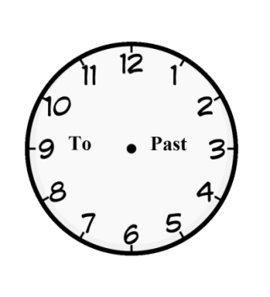b- 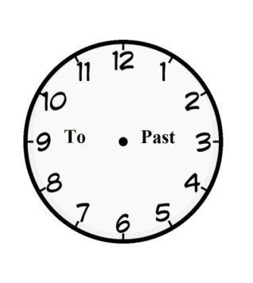 c- 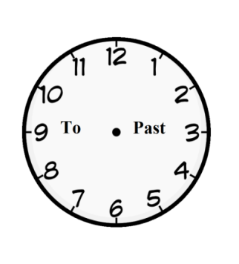

THE END
GOOD LUCK …
MaYaDa Al-NaSa’ah

Form#qf71-1-49rev.a

