فففغفغفغفغفغفغففففغفغلللل

25

Third month Exam
School: Amir Hasan elementary Boys /2
Name : ----------------------------- Class : ( )
-----------------------------------------------------------------------------------------------
QUESTION ONE Read and match 3 marks
It’s eight o’clock | It’s half past two | It’s one o’clock
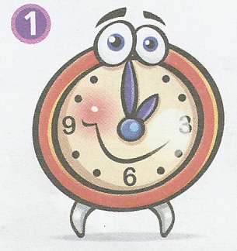
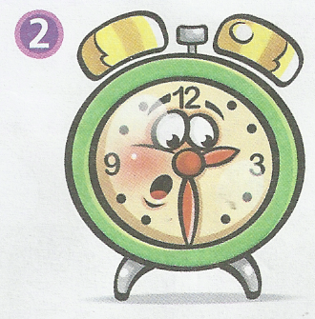
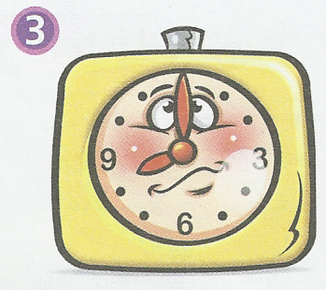

-----------------------------------------------------
QUESTION TWO look and match ( 3 marks )
nuts sweet cake
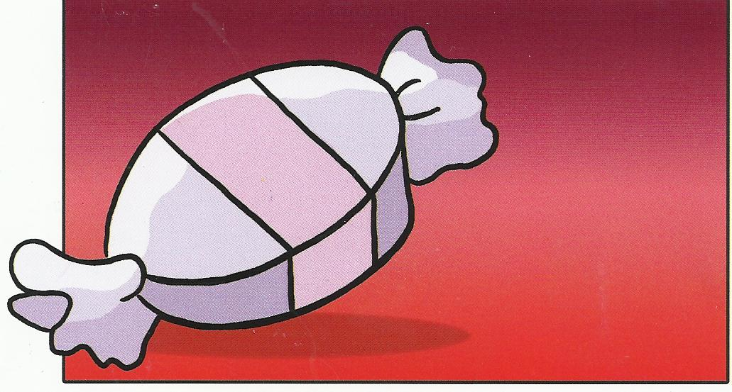
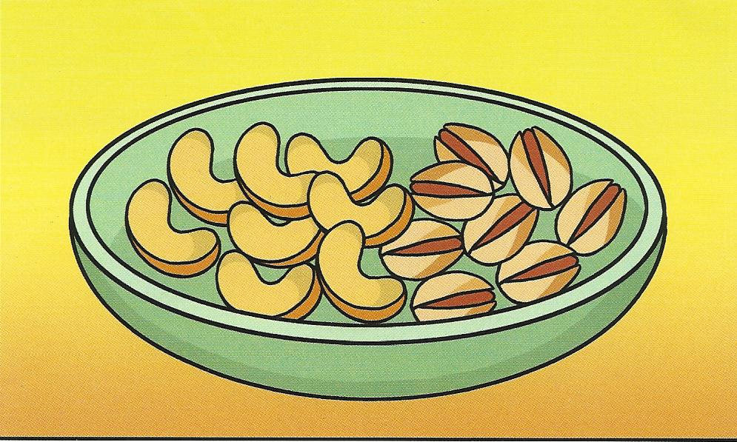
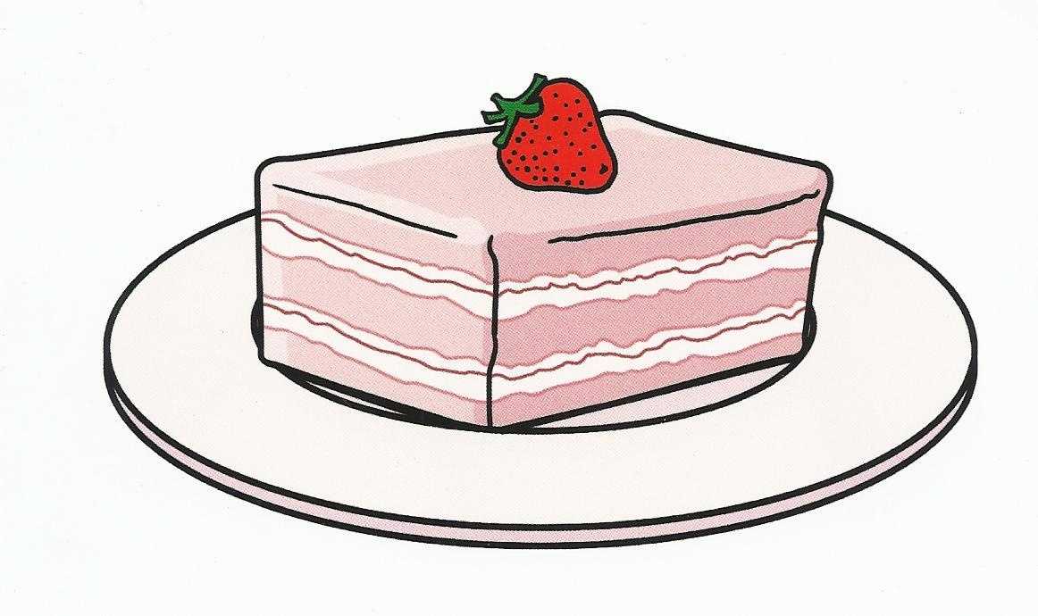

--------------------------------------------------
QUESTION THREE write the missing letter ( 2 marks )
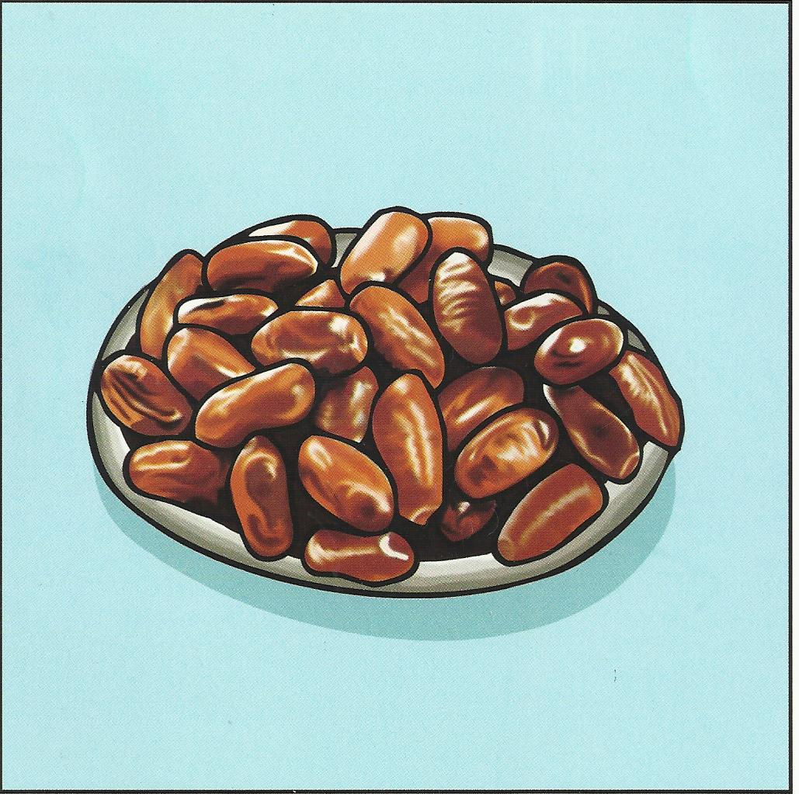
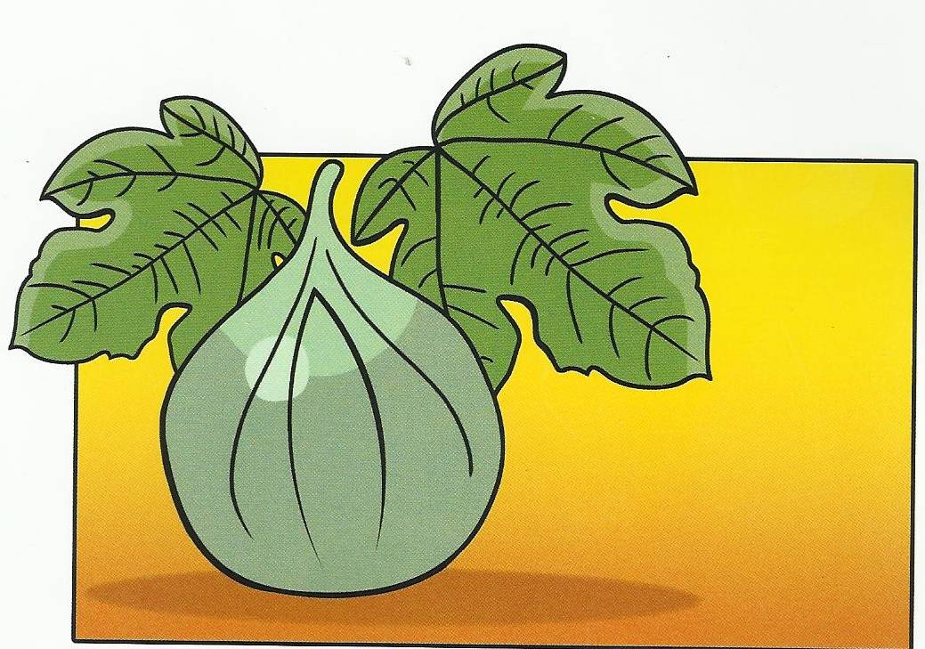
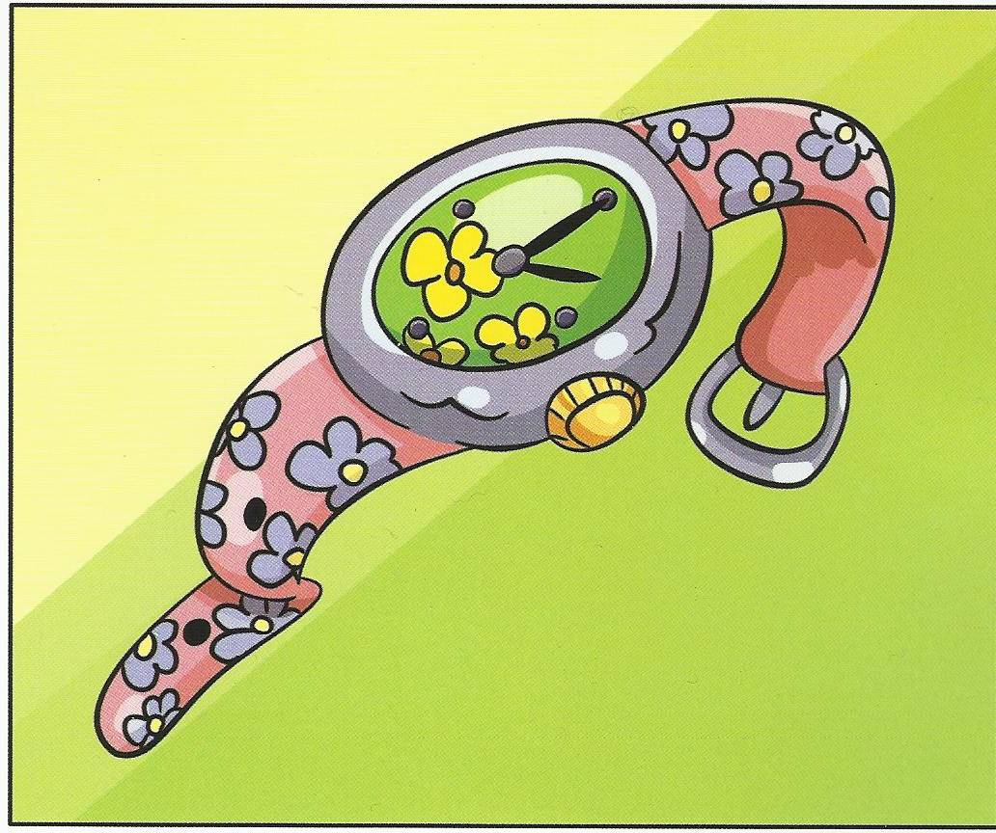
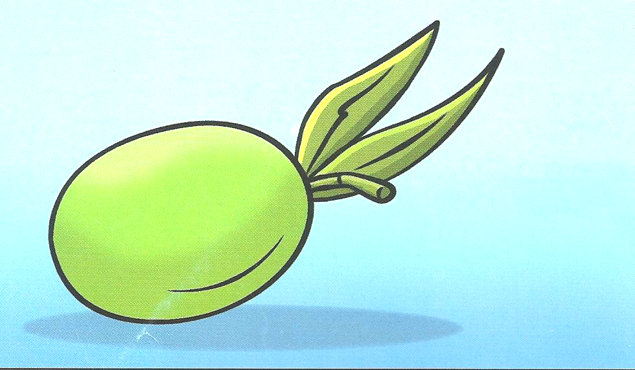

---ates ---ig ----atch ----live
-----------------------------------------------------
QUESTION FOUR Write the letters 5 marks

Aa |  |  |  |  |  |  |  |  |  |  | L l | Mm
Nn |  |  |  |  |  |  |  |  |  |  | Y y | Zz

-----------------------------------------------------
QUESTION FIVE Answer the questions ( 2 marks )
1 - What's your name ? --------------------------------------------
2 - What time do you get up ?--------------------------------------------

QUESTION SIX look, read and match ( 4 marks )
( 1 ) I get up at six o’clock .
( 2 ) I brush my teeth at half past six.
( 3 ) I go to school at seven o’clock .
( 4 ) I go to bed at nine o’clock .
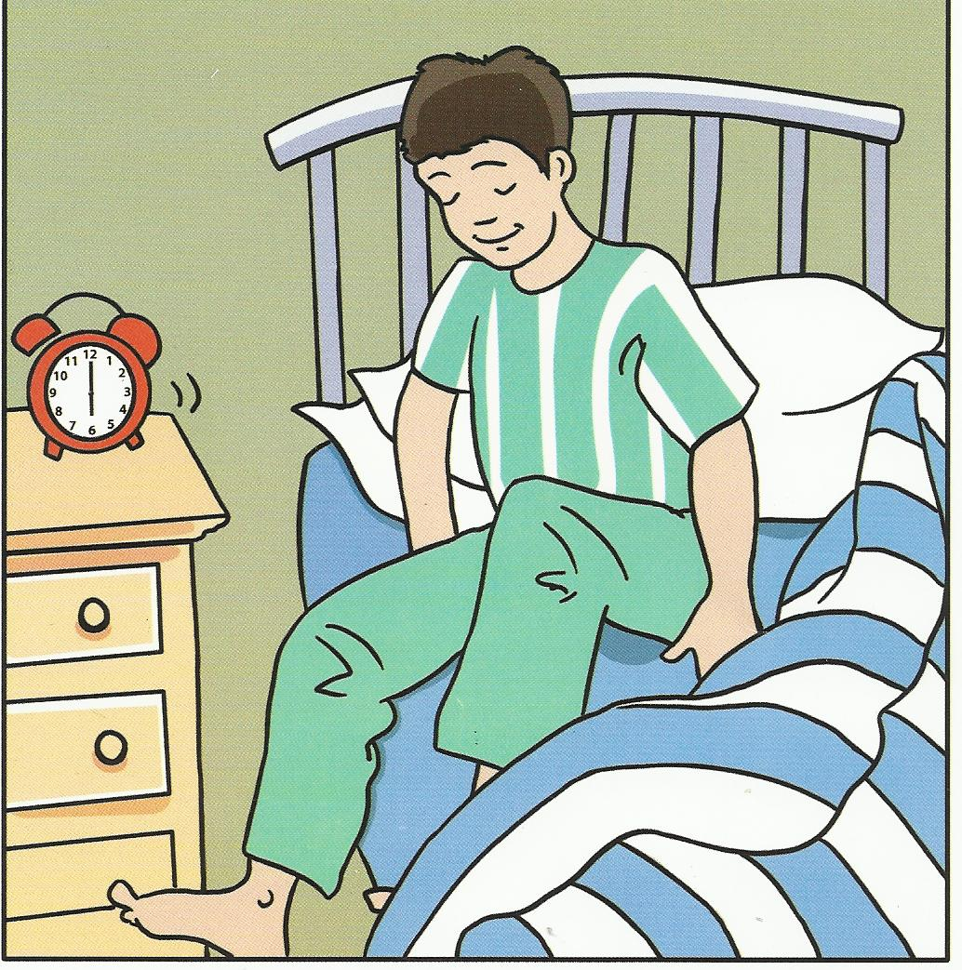
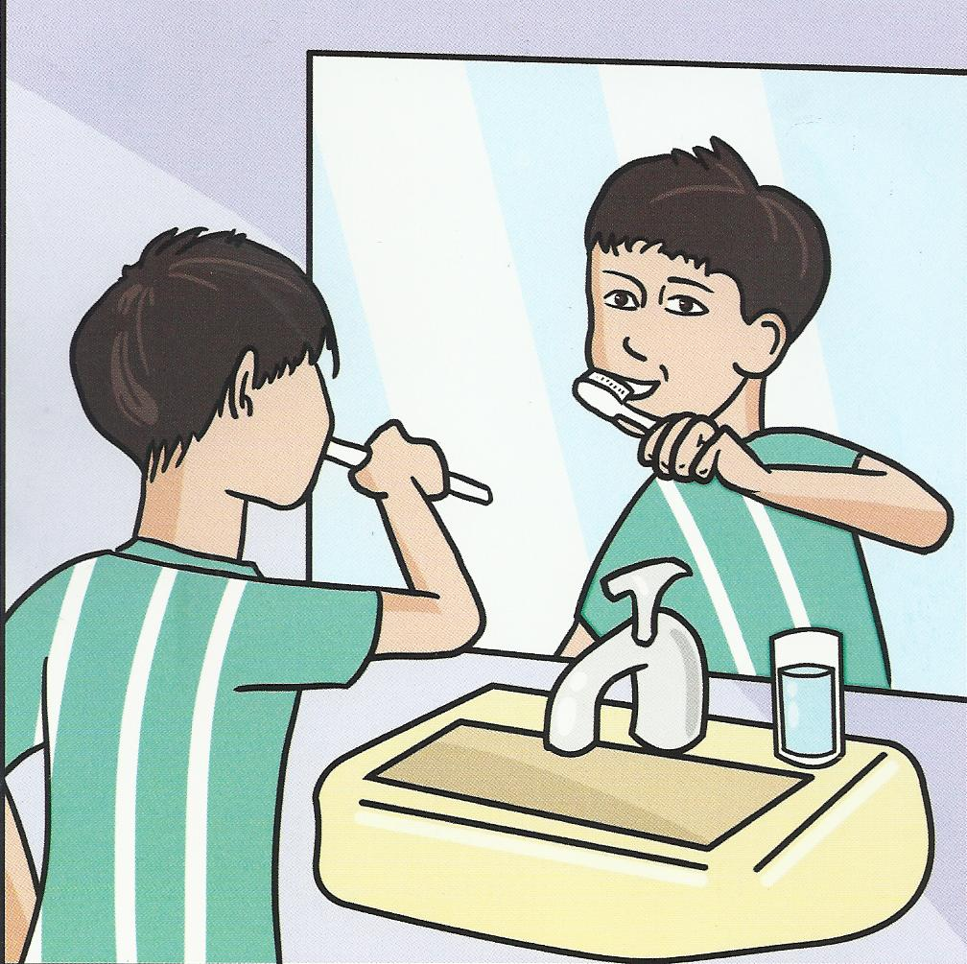
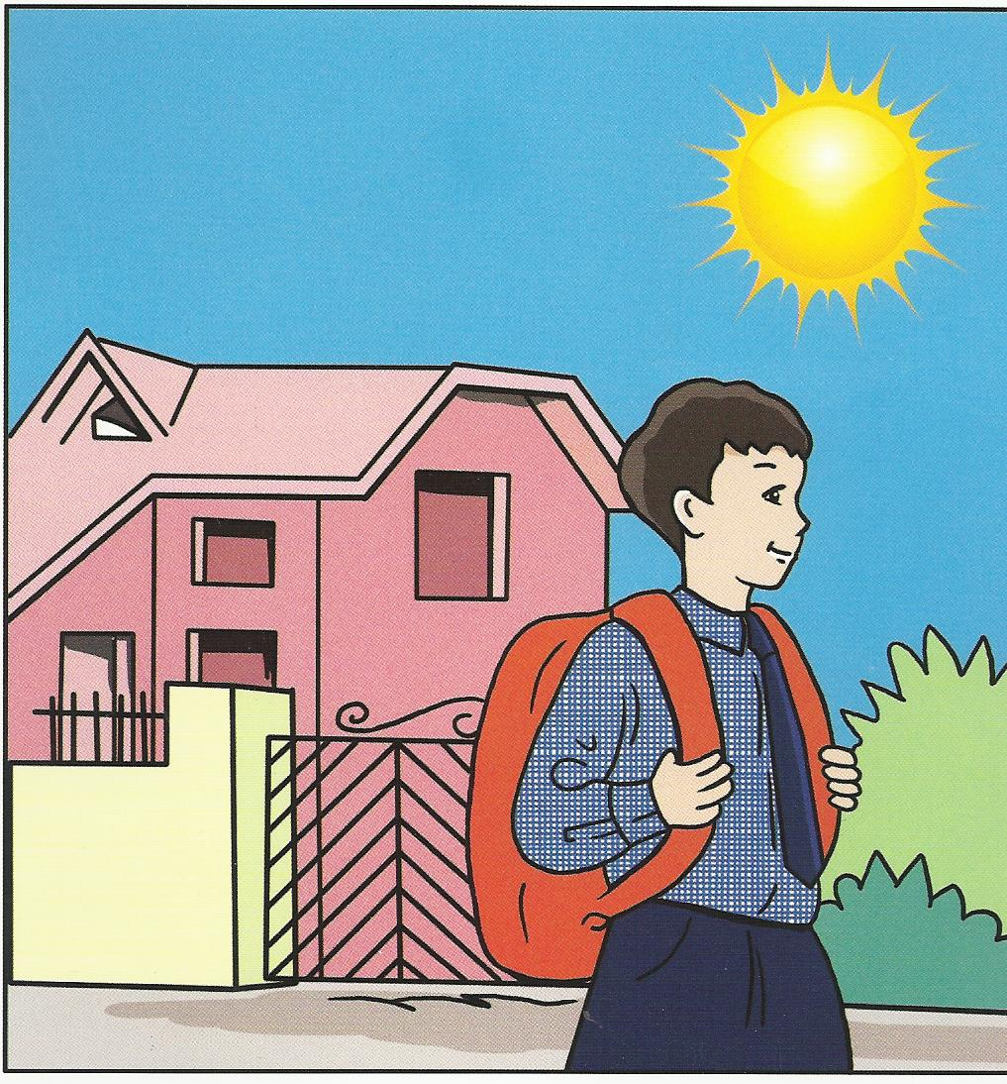
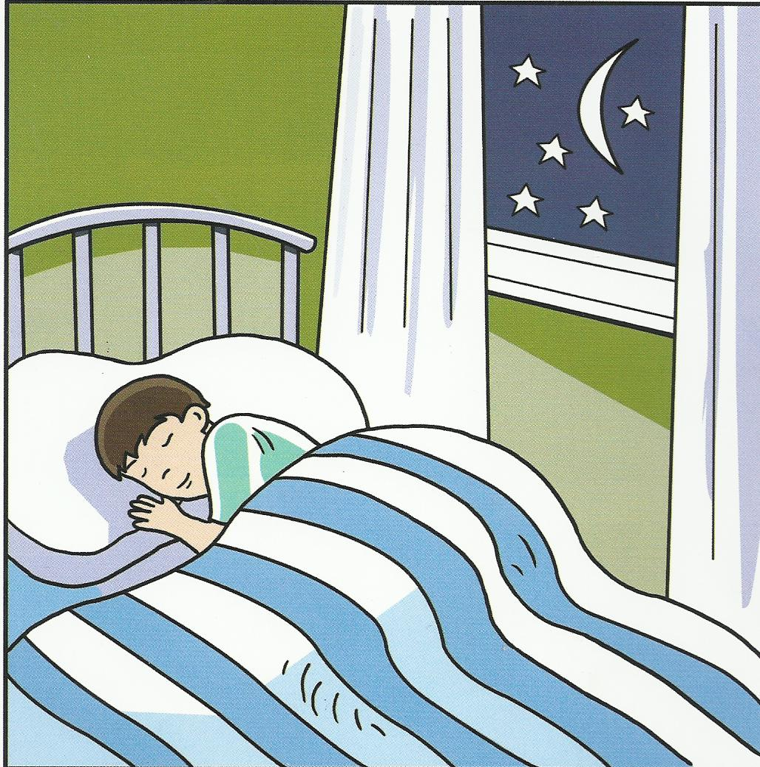

( ) ( ) ( ) ( )

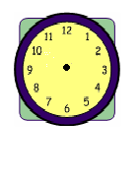
QUESTION SEVEN : Listen and draw the time (4 marks)

QUESTION EIGHT: 2- count and write the number ( 2 marks )
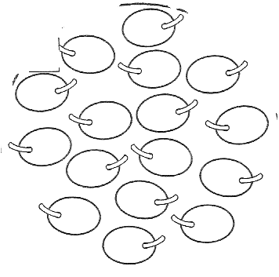
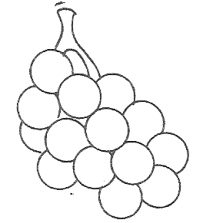

Good Luck
English teacher Emad Sbeihat

