

25

Department of Education / Zarqa Area
English Language Exam
Second Semester 2017 / 4016
School : --------------------------------------------
Name : ------------------------------------------------ 2nd Grade ( )
( 5 marks ) QUESTION ONE Write the missing letters
Aa |  | Cc | Dd |  | Ff | Gg |  | Ii
 | Kk |  | Mm | Nn |  | Pp |  | Rr
 | Tt | Uu |  | Ww | Xx | Yy
-----------------------------------------------------
QUESTION TWO look and match ( 3 marks )
watch dates fig
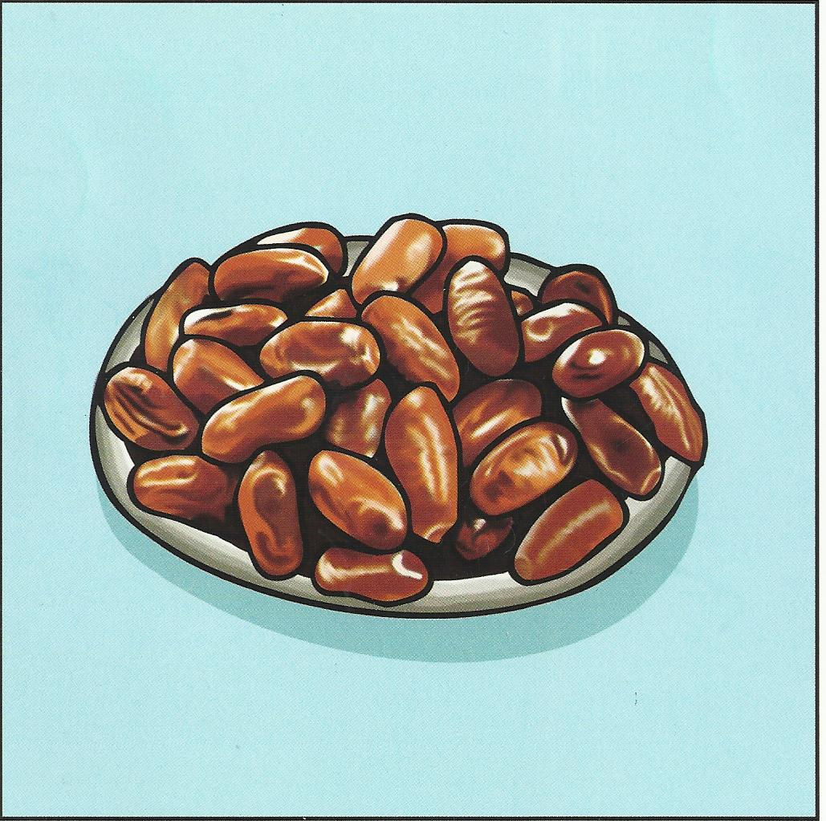
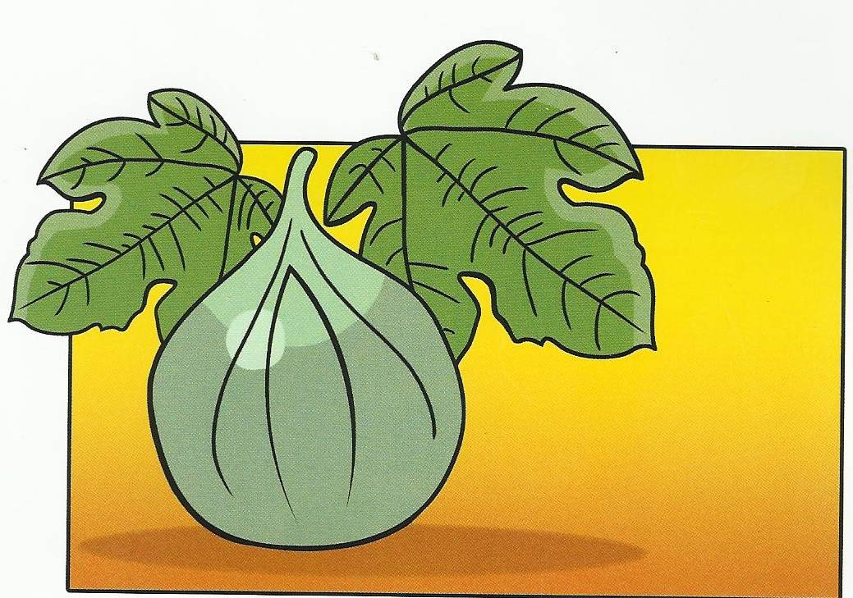
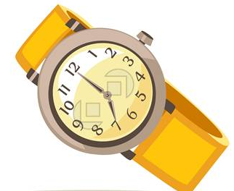

-------------- --------------- ------------- --------------------------------------------------
QUESTION THREE. Read the number words then write the numbers( 4 marks )

twelve | fourteen | eighteen | twenty-one
--------------------------------------------------
QUESTION FOUR write the missing letter ( 2 marks )
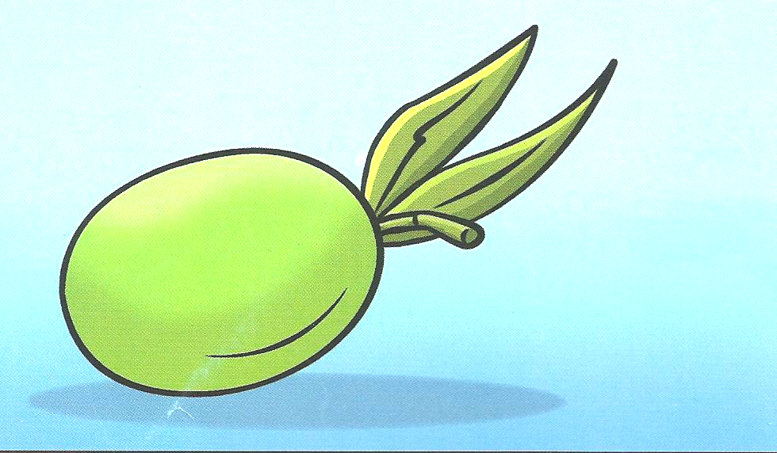
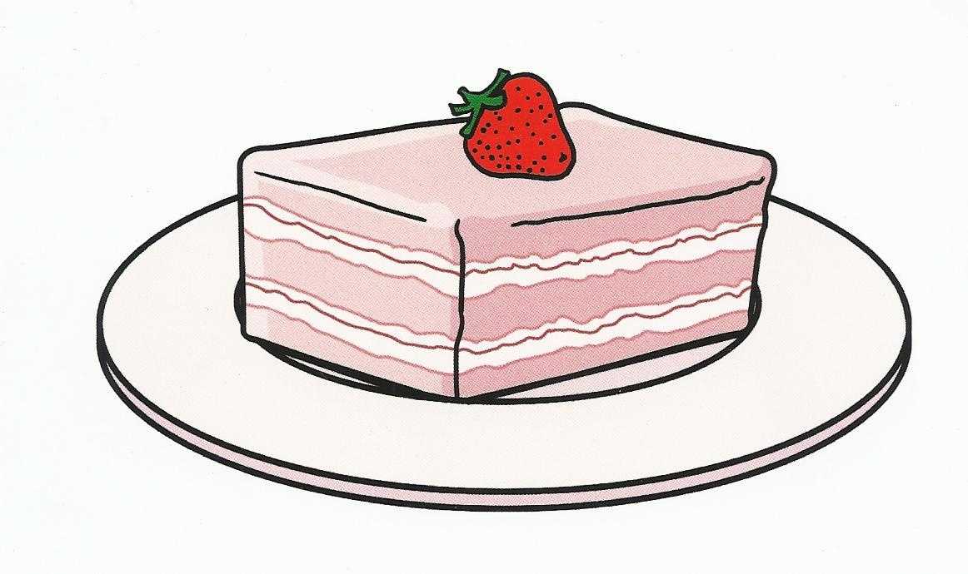

----ake ----live
QUESTION FIVE Read and match ( 3 marks )

It’s eight o’clock | It’s half past two | It’s one o’clock
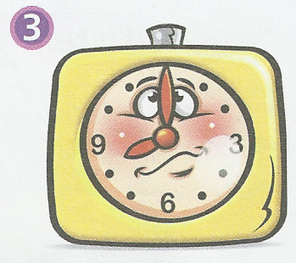
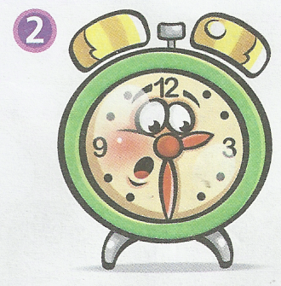
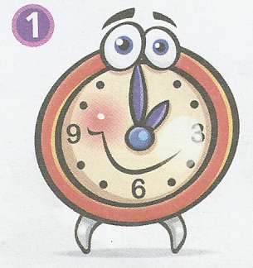

( 2 marks ) QUESTION SIX Copy correctly on four lines.

What time do you get up ?

QUESTION SEVEN : Listen and draw the time (2 marks)
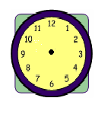

--------------------------------------------------
QUESTION EIGHT look, read and complete ( 4 marks )

get up | go to bed | brush my teeth | go to school
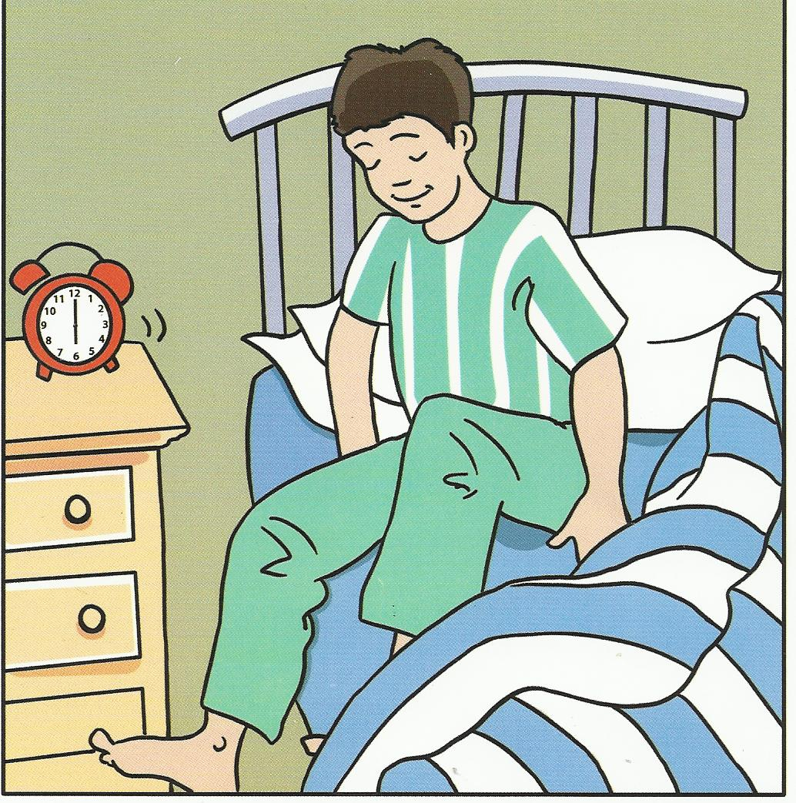
1 - I ---------------------------- at six o’clock .

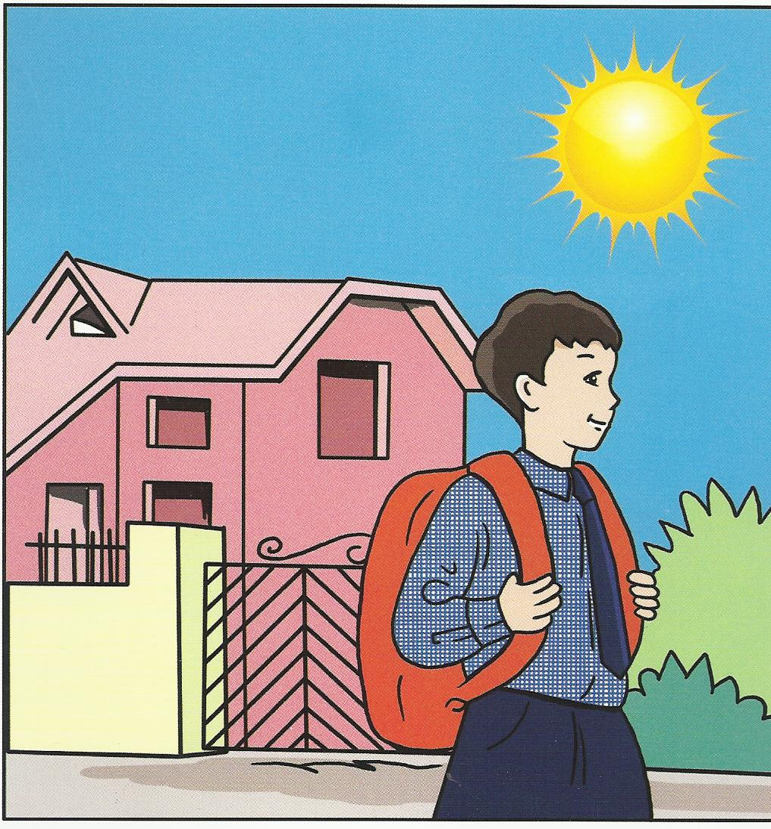

2 - I ---------------------------- at half past six .
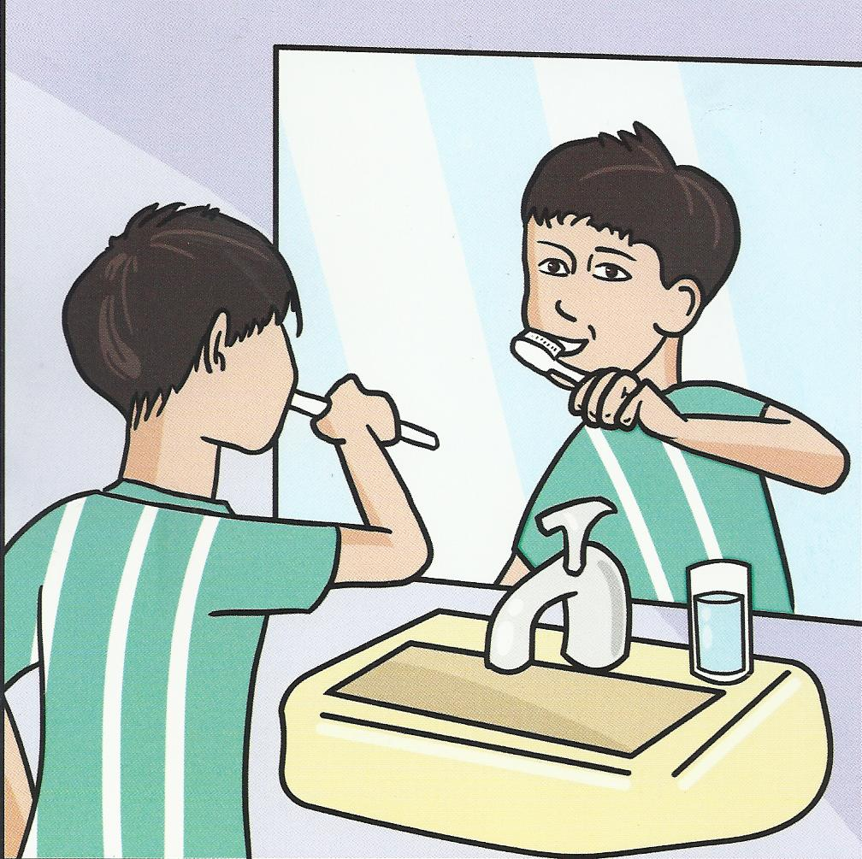

3 - I ---------------------------- at eight o’clock .
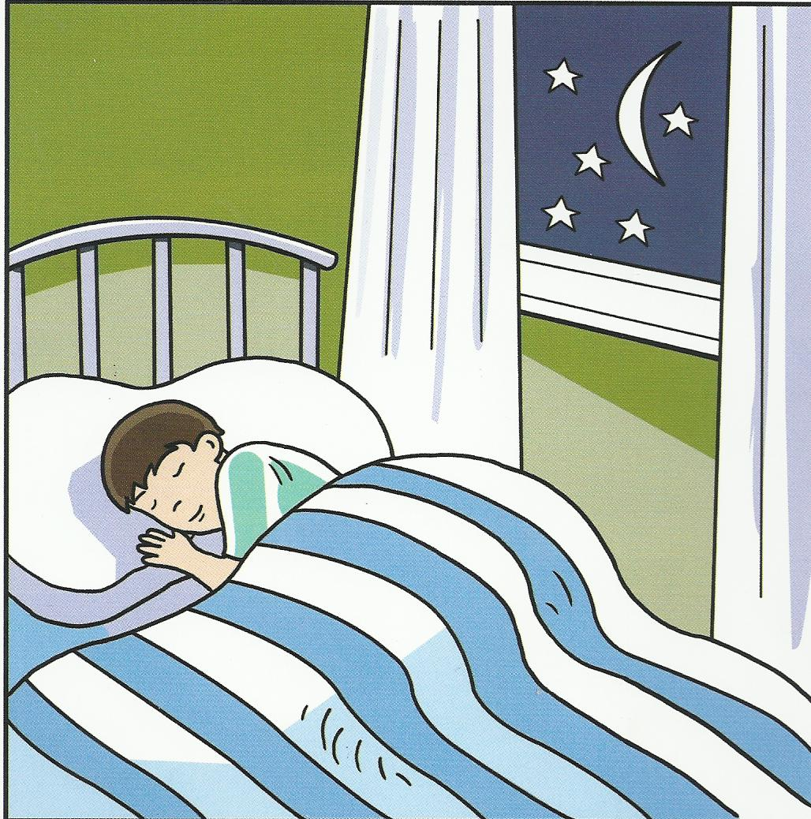

4 - I ---------------------------- at half past eight .
Good Luck
English teacher Emad Sbeihat

