2nd Grade What time is it? Name:----------------------------------------------------------------------------------------------------------------------------------------
Circle the correct answer .
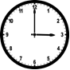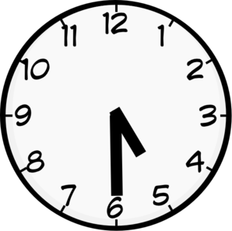
- It's three o'clock. A- It's five o'clock.
- It's half past three. B- It's half past five.
………………………………………………………………………………………………………………………………………
Draw the hands .
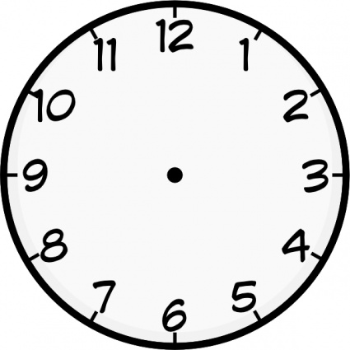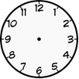
It's nine o'clock It's half past seven
………………………………………………………………………………………………………………………………………
What time is it?
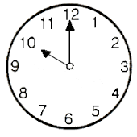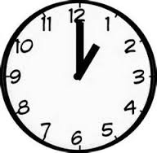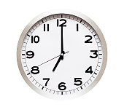
--------------------------------- -------------------------------- ----------------------------------
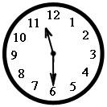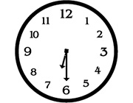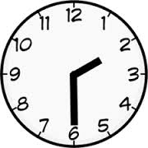
--------------------------------- ---------------------------------- --------------------------------

Write the words on the lines
What time is it ?

It's eleven o'clock.

It's half past twelve.
…………………………………………………………………………….
Reorder the following.
- time/ it / What / is ?.......................................................................................
- four/ It's / o'clock. ………………………………………………………………………………………..
- past/ half/ It's / ten ………………………………………………………………………………………..
………………………………………………………………………………………………………………………………………..
Reorder the following letters.
3 – e e r th ………………… 1- n o e …………………… 12 - w e t l v e……………………
………………………………………………………………………………………………………………………………………
