**Name: First English Exam 10th grade ( )**

**______________________________________________________________________________________**

**First Question:- Q1) Read the text then answer the questions below: (18 points)**

**The polar pear lives in the cold, snowy Arctic lands in the North Pole. *It* has a thick layer of fat underneath its skin and this helps to keep it warm. It also has a thick layer of fur all over its body, including the sole of its feet, which allows it to swim in the coldest seas without feeling the cold. Beneath the fur the skin is black, so it absorbs heat.**

**Unlike polar bears, penguins live in the South Pole and many live in Antarctica. Penguins keep warm with thick skin and lots of fat under the skin. Penguins have dark colored feathers on their back, which absorb heat from the sun to keep them warm>**

**\*\*\*\*\*\*\*\*\*\*\*\*\*\*\*\*\*\*\*\*\*\*\*\*\*\*\*\*\*\*\*\*\*\*\*\*\*\*\*\*\*\*\*\*\*\*\*\*\*\*\*\*\*\*\*\*\*\*\*\*\*\*\*\*\*\***

1. **Where does the polar bear live? …They live in the cold ,snowy Arctic lands in the North pole (2 points)**
2. **What do polar bears and penguins have in common? They both have a thick layer of fat underneath their skin (2 points)**

**How do penguins keep warm? (2 points) Penguins have dark colored feathers on their back, which absorb heat from the sun to keep them warm>**

1. **Give the word that means (The opening of the nose) nostril (2 points)**
2. **Write down the sentence which indicates that penguins do not live in the North pole: (2 pnts)**

**Unlike polar bears, penguins live in the South Pole and many live in Antarctica 6. What does the pronoun (*It*) in line (1 ) refer to? (2 points) The polar pear**

**______________________________________________________________________________________**

**Name the following animals:- (4ps)**

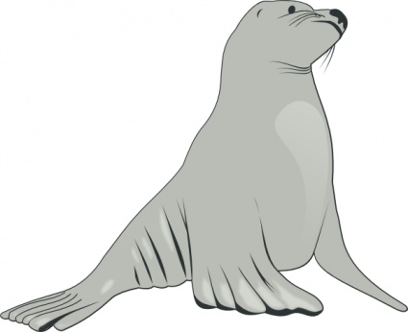

seal

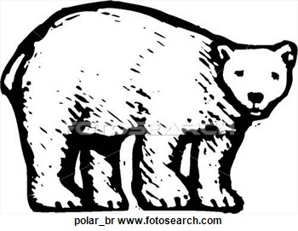

polarbear

**penguin 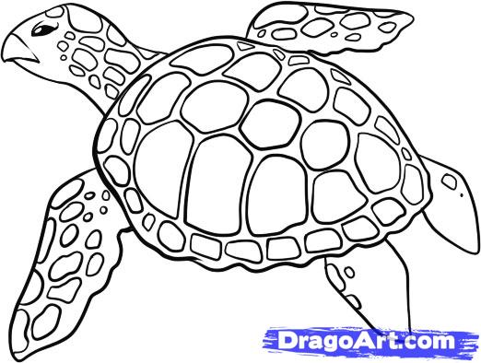 sea turtle**

**Q2) Fill in the gaps with one word from the box: (4 points)**

|  |
| --- |
| **Water proof , skis , scenary , guidebook , towel** |

1. I've been here for two days and I have seen some wonderful ***scenry .***
2. If you go to England ,you should take a ***towel*** --------- coat – It rains a lot .
3. It's useful to have a ***guide book***when you travel in a foreign country.
4. At the mountain resort, you can hire ***skis*** and a warm jacket for a skiing holiday

**Second Question:**

**Choose the best option for each sentence: (12ps)**

**(shall ….. ---- let’s ---- how about --- why don’t)**

**1) Hey Jim, why don’t you/ go to the movies with us?**

**2) What can we do this evening? Shall  we watch the game in a bar?**

**3) It's so hot in here! Lets  get out of here and go that bar near the bay!**

**4) Helen called and said she's going for a walk. How about  going with her?**

**5) I'd like to do something different this weekend...lets  go sailing!**

**6) A: What …shall …………. We do?**

**B: I don't know. It's not very warm and it looks as if it's going to start raining.**

**___________________________________________________________________________________**

* **Third Question: (8ps)**

**Fill in the blanks correctly:**

1. **She would be (be) happier if she had (have) more friends.**
2. **We would (buy) a house if we decided  (decide) to stay here.**
3. **If she weren’t  (not/be) always so late, she would be (be) promoted.**
4. **If we won (win) the lottery, we would travel (travel) the world.**

**_______________________________________________________________________________________________**

**Fourth Question: (4ps)**

**What would you do in the following situations? Write sentences using the second conditional.**

1. **You get lost in the city, I would get lost in the city if I didn’t have a guide book**
2. **You found a valuable item in the street . If I found a valuable item in the street , I would give it to the police**

**_________________________________________________________________________________________**

**Correct the mistakes in the following sentences . (6ps)**

**1. If you *goes* to the Poles , you would *saw* a lot of snow and ice.( Went , see)**

**………………………………………………………………………………………………………………………………………………………………………..**

**2. If I were you , I *will helps* my mother .would help**

**…………………………………………………………………………………………………………………………………….**

**3. Why don’t we *did* the homework? do**

**…………………………………………………………………………………………………………………………………………………..**

***Good Luck***

***Prepared by : Somayah Al- Maaitah***